
JUNIOR HIGH/MIDDLE SCHOOL CHORAL HANDBOOK
TABLE OF CONTENTS
INTRODUCTION AND OVERVIEW 3
ORGANIZATIONS 4
BUSINESS MEETINGS 5
MAP TO MHSAA 6
MMEA LEADERSHIP 7
MSACDA LEADERSHIP 8
MISSISSIPPI HIGH SCHOOL ACTIVITIES ASSOCIATION 9
GENERAL INFORMATION 10
STUDENT ELIGIBILITY RULES 10 - 14
FORM 1 15
APPLICATION FOR BORDERING STATE EVENTS 16
APPLICATION FOR NON-BORDERING STATE EVENTS 17
SOLO AND ENSEMBLE FESTIVAL 18
SOLO AND ENSEMBLE FESTIVAL INFORMATION 19 - 20
SOLO AND ENSEMBLE REGISTRATION FORM 21
SOLO AND ENSEMBLE EVALUATION FORM 22
SOLO AND ENSEMBLE VIRTUAL SUBMISSION GUIDELINES 23
RECOMMENDATIONS FOR JUNIOR HIGH SOLOS 24
MASTER CLASS SUBMISSION 25 - 26
STATE PERFORMANCE ASSESSMENT 27
ADJUDICATION 28
GENERAL FACTS 28 - 29
VOICE CATEGORIES 29
FEES AND FORMS 29
SIGHT-READING 30
GENERAL INFORMATION 30
PROCEDURE FOR SIGHT-READING ADJUDICATION 30 – 31
GUIDELINES FOR MELODIC/RHYTHMIC PATTERNS 31 - 32
RUBRICS 33 - 34
STATE PERFORMANCE ASSESSMENT REGISTRATION 35
INVOICE 36
STATE FESTIVAL ADJUDICATION FORM 37 - 38
SIGHT-READING ADJUDICATION FORM 39 - 40
HONOR CHOIR AND MMEA/ACDA CONVENTION 41
JR. HIGH HONOR CHOIR OVERVIEW 42
GENERAL AND SPECIFIC INFORMATION 42
AUDITION AND SELECTION PROCESS 42
DURING HONOR CHOIR 42 - 43
HONOR CHOIR REGISTRATION FORM 44
PHOTO/VIDEO RELEASE FORM 45
MMEA/ACDA CONVENTION 46
GENERAL INFORMATION 46
PROCEDURE FOR PERFORMANCE SELECTION 46
MENTOR PROGRAM 47
MENTOR PROGRAM INFORMATION 48
MENTOR APPLICATION FORM 49
CHORAL ART FESTIVAL 50
GENERAL INFORMATION 51 - 52
CHORAL ART APPROVAL FORM (FORM 8) 53
CHORAL ART REGISTRATION FORM (FORM 9) 54
CHORAL ART CHOIR INFO ADDENDUM 55
CLINICIAN COMMENT FORM (FORM 10) 56
SIGHT-READING RUBRIC 57

MMEA JUNIOR HIGH/MIDDLE SCHOOL CHORAL HANDBOOK
INTRODUCTION
Welcome to the Junior High Division of MMEA. This handbook is designed to help all junior high/middle school directors in their endeavors for a successful choral program for their students. Please be sure to read the entire handbook and continue to refer to it throughout the year. If questions or problems exist, contact your district or state chairperson.
PURPOSE
1. To introduce the junior high and middle school student to the art of performing vocal literature:
a. Music representative of ethnic cultures
b. Music representative of the various seasons
c. Patriotic music
d. Sacred music
e. Folk music
f. Music of various historical periods.
2. To provide the Junior High and Middle school student with supervised opportunities for public performance.
3. To promote and improve the assessment and adjudication of choral ensembles at the junior high level.
THE DIRECTOR’S RESPONSIBILITIES
1. To read, comprehend, and understand this handbook
2. To attend all meetings
3. To contact district or state chairperson when needed

ORGANIZATIONS
MHSAA – Mississippi High School Activities Association
1. Sanctions the MMEA Junior High Choral Division’s Regional State Performance Assessments
2. Promotes the general welfare of the Junior High and Middle schools in their relationships with each other through planning, directing and controlling contests, games, and other inter-scholastic activities and through defining and fixing responsibility
3. MHSAA Executive Director helps our choral programs develop by working toward a well-rounded activities association and by supporting our efforts toward growth with time and financial help.
NAfME – The National Association for Music Education
1. National umbrella organization for choir, general music, orchestra, band, keyboard, research, guitar, jazz, history, and theory and composition 2. Benefits teachers of students from pre-school through college and other involved in adult groups, music administration, private/studio instruction and teacher education
3. Membership of MMEA automatically makes you a member of NafME (National Association for Music Education)
ACDA – American Choral Directors Association
1. National organization for choral directors in the following classifications: SATB/mixed, men, women, boy, girl, ethnic, jazz/show, and children’s choirs
2. Benefits directors of singers from elementary through college, music administrators, and other directors involved in community, church, and professional choirs
3. Membership of ACDA automatically makes you a member of MSACDA (Mississippi American Choral Directors Association)
4

BUSINESS MEETINGS
These meetings are extremely important professional responsibilities – state officers need input from ALL members. You must be present to vote on business matters.
1. MEETINGS – 2 official
- August – usually the second Saturday
- MMEA/ACDA annual convention (January 2024)
- Notices of the official meetings are to be distributed by the State President and can be found on the M.M.E.A. website, www.msmea.org.
2. VOTING
a. Only MMEA members vote – others may attend but cannot vote
b. Officer elections require only one vote total – all other motions made must receive a majority positive vote at two business meetings before they are placed in effect.
3. WHAT WE DO
a. Discuss old and new ideas, procedures, needs, regulations, etc.
b. Make decisions
c. Make and vote on motions
d. Form committees
e. Elect officers
f. Clarify and update MHSAA information
g. Network
The August meeting is usually held at the Mississippi High School Activities Association Building located in Clinton. Directions to MHSAA are as follows:
Take I-20 to Exit 35 Clinton-Raymond Road. Turn south. The MHSAA building is located at 1201 Clinton-Raymond Road (the first building on the right). Proceed to the traffic light and turn right onto the frontage road. The entrance to the MHSAA building is the second drive on the right. Map provided on the next page.
5

MHSAA Building – Take Exit 35 – 1201 Clinton Raymond Road 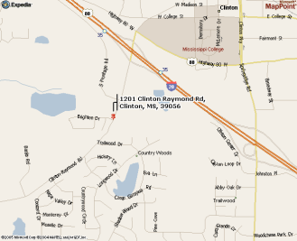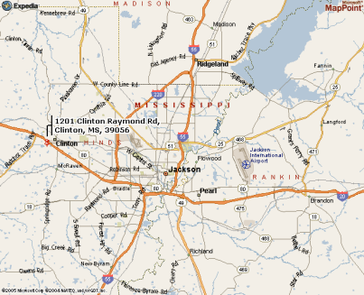6

MISSISSIPPI MUSIC EDUCATORS ASSOCIATION
LEADERSHIP
President – Andy Beasley
President Elect – Tammy Carney
Past President – Jennifer Davis
Secretary – Mary Leigh Ochoa
Treasurer – Rachel Landrum
BOARD OF REPRESENTATIVES
High School Choral Division
President – Jordan Langworthy
President–Elect – Daniel Vernon
Past President – Jana Smith
Secretary – Katherine Freeman
Junior High Choral Division
President – Ginger Partain
President–Elect – Dr. Lynn Holliman
Past President – Sue Tarver
Secretary – Mitchell Crawford
SSA Honor Choir Chair – Jamie Lee Moore
Elementary Division
President – Tab Ash Keeton
President–Elect – Jennifer Timidaiski
Past President – Princess Thompson
Honor Choir Co-Chair – Caysee Sanders
Honor Choir Co-Chair – Dr. Bobby Helms
ADVISORS
Tri-M Advisor – Pertrina Judon
Arts Education and Advocacy – Hannah Gadd Ardrey
Coalition and Retired – Dr. Mark Malone
Collegiate Advisor – Dr. Jonathan Kilgore
Social Media Advisor – Jennifer Timidaiskai
State Arts Coordinator – Limeul Eubanks
Webmaster – Tab Ash Keeton
Conference Registrar – Joel Hill
Early Childhood – Heather Howell
Mentorship – Terrell Hall, Tommy Creel & Daniel Vernon
Membership – Pam Moody & Angie Rawls
Undergraduate Advisors - Melody Rawls, Benton Donahue, & Finn Sobalvaro
Journal – Sarah Little, Cody Nelson, & Princess Thompson
7
MISSISSIPPI ACDA LEADERSHIP
President – Dr. Libby Hearn
President-Elect –
Past President – Dr. LaDona Tyson
Treasurer – Alison Custer
Secretary – Dr. Jonathan Kilgore
Conference Registrar – Joel Hill
REPERTOIRE AND RESOURCES CHAIRS
Repertoire Specific Coordinator - Allen Sanders
Contemporary & Commercial - Jeffrey Coulter
High School Show Choir - Toney Keeler
Jr. High Show Choir - Sam Lovorn
Treble Choirs - Dale Beech
World Musics & Cultures - Brandon Cash
Youth Choirs & Student Activities Coordinator - Dr. Philip Stockton
Jr. High/Middle School - Olivia Dunn
Senior High School - Terrell Hall
Collegiate Coordinator - Dr. Don Trott
Two-Year College - Dr. Kelvin K. Towers
Lifelong Choirs Coordinator - Dr. Julia Thorn
Music in Worship - Katie Barr
MEMBERSHIP
To join National Association for Music Education (NAfME) visit www.nafme.org and complete the online application.
To join American Choral Directors Association (ACDA) visit www.acda.org and complete the online application.
8
MISSISSIPPI
HIGH
SCHOOL
ACTIVITIES
ASSOCIATION 
9

MHSAA INFORMATION
GENERAL INFORMATION
1. Directory Form – This form will be set by MHSAA. It must be completed and returned to MHSAA by September 15. Choral directors must be registered before they can participate in any MHSAA activities. This information is also used to compile a choral director’s address and phone directory that is sent to all choral directors in the state.
2. Insurance – The students registered with MHSAA on the eligibility list are automatically covered with catastrophic insurance for activities sponsored or sanctioned by MHSAA such as District Festival, State Festival, Honor Choirs, and out-of-state trips. Students MUST be enrolled in Dragonfly Max in order to be deemed eligible and be covered under the insurance.
3. Bordering States – If you take students to a choral event in a bordering state, you must submit the appropriate form to MHSAA (found in this section and the forms section) in order for the catastrophic insurance to apply.
4. Other Trips – If you take students to a choral event outside of the bordering states boundary, you must write MHSAA for permission to guarantee insurance.
5. Conflicting Schedules – Be sure you keep up with your school’s calendar to avoid major conflicts. MHSAA sets our state adjudication date more than one year in advance.
General Eligibility Rules
1. To be eligible to participate in interschool activities, a contestant must:
a. Be a bona fide student, having enrolled not later than the 15th day of any semester of participation, carry the required number of subjects for graduation by their local district and deport himself satisfactorily.
b. Upon the completion of grade eight, choose the high school he/she wishes to attend in a city or district where there are two or more high schools or schools of secondary grade. When a student has chosen a high school and enrolled in and attended that school for one day or longer, the school of his choice shall become his home school. In a junior high school situation, the choice of grade nine in a given junior high school means the choice of the senior high school, which is designated by the appropriate school board as the senior high school for the graduates of that particular junior high school. Any pupil who enters grade 9 in a member public junior high school or grade 10 or above in a member public high school and then transfers to a member private or parochial high school shall be ineligible for a period of one year. The same is true where a pupil enters grade 9 in a member parochial or private junior high school or grade 10 or above in a member parochial or private high school and then transfers to a member public high school. Upon transfer from the first member high school chosen to the second member school, he will be ineligible for competition in either athletic and literary contests or meets until he has been in the second school for one year from the date he enrolls in the second school.
10
c. In the case of a transfer student, the school shall secure a transcript of the school work completed by the student and a transfer form signed by the principal of the school from whence he comes. The transfer form for out-of-state transfers shall give the date the student entered the ninth grade and whether he passed his work during the preceding year. If any school should refuse or delay unnecessarily in sending the transcript or the transfer form, when requested by the receiving school to do so, the Executive Director may, upon the presentation of satisfactory proof, authorize the school to use the student in athletic contests prior to the receipt of the transcript and the transfer form. A transfer student is one whose parents or guardian has moved from one school district to another and established a bona fide residence therein for some other purpose than conferring athletic or interscholastic eligibility on the student. Any transfer student must be in good standing from the school he/she is leaving in order to receive eligibility at his/her new school. This includes MHSAA member schools, as well as non-member schools and students transferring from out of state. Any student who transfers during a sport season, even after making a bona fide move, must be approved for participation in the same sport season.
d. Foreign Student Eligibility - a bona fide foreign exchange student may be immediately eligible the first year in residence in the school district in which the host family is a bona fide resident and be limited to one year of eligibility provided the student is a participant in an established foreign exchange program accepted for listing by the Council of Standards for International Education Travel (CSIET), and there is no evidence of athletic recruitment resulting in the student’s attendance at the school either by the school or any other outside entities. The foreign exchange student shall meet all other eligibility requirements of the MHSAA Handbook. Any student that has established eligibility at a Mississippi school and participates in a Foreign Exchange Program sponsored by a CSIET approved program will be eligible for participation immediately upon his/her return to the same Mississippi school. The student shall meet all other requirements for eligibility as listed in the MHSAA Handbook.
e. Eligibility Reporting – The report submitted to the State Office becomes a permanent record. Care should be utilized to have the eligibility complete and correct as an error on the original filing can cause difficulty one to three years later. The school should report each student only once during a school year. Eligibility is by semesters and not by sports. At the beginning of each school year, student eligibility should be updated 15 days prior to the first game or contest. Schools that are late in filing eligibility will be fined $50.00. Players participating in athletics or activities may be added to or changed after the beginning of the season, provided the pupils are not allowed to participate in a game or contest until properly reported. The list of players participating in athletics or activities may be added to or changed after the beginning of the season, provided a pupil is not allowed to participate in a game or contest until properly reported. Each school shall keep a file copy of the eligibility sheets.
2. Academic rules for students participating in activities:
To be eligible for athletics and activities, students must pass the number of courses required by their local district in order to stay on graduation track. The units will be averaged as a whole, either numerically or by GPA, and must be 2.0 or better each semester in order to maintain eligibility.
A student athlete may become eligible for the second semester only once during his/her middle/junior high school career if he/she fails the year-end average the previous year, by passing the required number of units with a 2.0. This will be done in order to keep the student on track for graduation.
11

NOTE: Detailed information on eligibility can be found on the MHSAA website, www.misshsaa.com, home page under ―Eligibility.
Special education students will be academically eligible if they are making satisfactory progress according to the committees reviewing their Individual Education Plans (IEP).
Out of School One or More Semesters: If a pupil who is eligible for a given semester drops out of school for one or more semesters, he/she is then ineligible until he/she passes the required number of courses with an overall average of 2.0 during a semester. A pupil who is eligible for a given semester cannot drop out of school during the semester or remain out of school for one or more semesters and then be eligible for the next semester he attends.
SEVENTH, EIGHTH AND ENTERING NINTH GRADE PARTICIPATION: Pupils in the seventh grade, eighth grade, and entering the ninth grade participating in high school extra-curricular activities must have a 2.0 overall average (computed numerically or by GPA) for the four core courses (English, math, science and social studies) from the preceding semester. The year-end average for the spring semester will be used to compute averages for the fall semester. Students must be on track to be promoted to be eligible.
If a student meets promotional requirements at the end of the school year but is retained in the same grade, the student is ineligible for one (1) year. This is commonly referred to as redshirting. If the student participates after being declared ineligible, the school will be placed on athletic probation by the MHSAA. Also, the school could lose accreditation by the State Department of Education.
SUMMER SCHOOL CREDITS: An accredited summer school shall be considered as an extension of the second semester of the school session, and credits earned in such a school may be considered in determining the scholastic eligibility of students. The completion of a full unit, major subject, during a summer school shall be classed as passing one major subject for one unit of credit and not as passing two major subjects for one half unit each. Accredited correspondence courses may be accepted for establishing athletic eligibility provided the course has been completed and recorded by the opening of school.
Exceptions to Rule (1) may be made by the Executive Director in the following cases:
1. Students that have been tested, screened, and placed in a TMR or EMR Special Education program.
2. Students that have been tested, screened, and placed in accordance with their IEP in a Special Education Program approved by the State Department of Education will be ruled eligible with the following requirements:
a. Make satisfactory progress in their course work.
b. Maintain attendance according to district policy.
c. Be assigned a date of entering the ninth grade corresponding to other students of that age.
d. Be subject to all other rules and regulations of the MHSAA. 12

General Eligibility Rules, Junior High/Middle Schools
To be eligible to participate in interschool Junior High/Middle activities, a contestant must:
a. Be a bona fide student having enrolled not later than the fifteenth day of any semester of participation, carry four basic courses* and deport himself satisfactorily.
b. A pupil must attend school in the school district of which his parents are actual bona fide residents.
c. A student must pass their grade level by achieving at least an average of 2.0 in four basic courses* the previous semester (computed numerically or by GPA). The year-end average for the spring semester will be used to compute averages for the fall semester.
d. To be eligible for participation as a seventh grader a student must be promoted with an average of 2.0 from sixth to seventh grade and for participation as an eighth grader a student must be promoted from seventh to eighth grade with a 2.0 average.
e. A pupil who is not eligible at the beginning of the school year may become eligible the second semester only once during the student’s junior high school career by passing four basic courses with an overall average of 2.0.
f. The instructional program of the district is based on an instructional management plan/system that defines core objectives, standards of mastery, and criteria for the academic promotion/progression of students from one grade level to the next. The criteria prohibit the retention of students for extracurricular purposes.
g. Have on file with the Executive Director at least 15 days prior to the first game or contest the eligibility list giving all information on the form required by the Director.
h. Age: Seventh grader must not have reached 14 years of age prior to August 1. Eighth grader must not have reached 15 years of age prior to August 1.
Ninth grader must not have reached 16 years of age prior to August 1.
i. Sixth grade students are no longer eligible to participate in MHSAA sponsored events; however they are eligible for participation in MMEA events, such as the Choral Art Festival, Solo & Ensemble, and All-State Honor Choir. In such cases, catastrophic insurance through MHSAA is unavailable. An entire choral program may be put on probation if caught using ineligible students. Do not risk probation for your group. Take the time to know and follow the rules.
* Basic courses - Any subject that meets the equivalent of at least 250 minutes per week or meets the State Department requirement.
13

To be eligible only for middle/junior high activities, a student must have passed any four courses (that meet the equivalent of 250 minutes per week and meet MDE requirements) with a 2.0 average for the preceding semester (computed numerically or by GPA.) The year-end average for the spring semester will be used to compute averages for the fall semester. Students must be on track to be promoted to be eligible.
To be eligible for high school activities, the middle/junior high school students must have a 2.0 overall average (computed numerically or by GPA) for the four core courses (English, math, science, and social studies) from the preceding semester. The year-end average for the spring semester will be used to compute averages for the fall semester. Students must be on track to be promoted to be eligible.
Summer school, or extended school year grades will replace the grade for a failed course in the spring semester GPA.
The following information regards tuition students:
A student who has spent one school year in a school other than his/her home school (bona fide residence of parents) without participating in interscholastic sports/activities and has been released by the home school is considered to be eligible. Eligibility can be established only during the year immediately preceding participation. All students who do not live with their parents for any reason are considered under this rule.
Once a student sits out a year, that school will become their home school. A student is not eligible to return to their former school and become eligible unless they sit out a year or establish a bona fide residence move.
You may read more information on the MHSAA website at misshsaa.com
14

^{TO: Choral Directors} FORM 1
FROM: Rickey Neaves, Executive
Director RE: Registration
THIS IS IMPORTANT--In order for the choral director to be registered with MHSAA and so that plans
can be made for District and State Choral Festival, please complete the information requested below. If this
form is not returned by the deadline the choral director and school will not be registered in the MHSAA Choral
Directory or be allowed to participate in Choral Festivals. This form should be in the office of Mississippi High
School Activities Association by September 15. If the form is not received by this date it is assumed that the
school does not have a choral director and does not plan to participate in any way. A copy of the current MHSAA
Handbook has been given to the Principal for the Choral Director.
1. Name of Choral Director ____________________________________________________
2. Name of School ___________________________________________________________
3. Address of School _________________________________________________________
4. City ____________________________ Zip __________________________________

5. School Telephone of the Choral Director ( ) _______________________________

6. Home Address of the Choral Director __________________________________________

7. City ____________________________ Zip __________________________________

8. Home Telephone of the Choral Director ( ) ________________________________

9. Email Address _________________________ Fax # ( ) __________________

10. Total Enrollment of School ________________

11. Number of Students in Chorus: Girls ________ Boys _________ Total ________

Please forward the above information by September 15 to:
Mississippi High School Activities Association, Inc.
P.O. Box 244
Clinton, MS 39060-0244
Or Fax to: 601-924-1725
________________________________ ________________________________
Choral Director Principal

Please return to MHSAA by September 15 15
MISSISSIPPI HIGH SCHOOL ACTIVITIES ASSOCIATION, INC.
P.O. BOX 244
CLINTON, MS 39060-0244
or Fax to: 601-924-1725
APPLICATION FOR BORDERING STATE EVENTS
All contests held between Mississippi high schools and schools from bordering states must be sanctioned by the Mississippi High School Activities Association. Applications are to be initiated by the sponsoring school no later than 30 days prior to the date of the competition.
Name of School ____________________________ Date ______________________ Signature of Principal _________________________________________________________
Section 1
We request to participate in the following events (AWAY):
School | State | Date of  Event | Activity | Boys | Girls

Section 2
We desire to invite schools from other bordering states (HOME):
School | State | Date of  Event | Activity | Boys | Girls

Section 3
Endorsement of MHSAA
This event is APPROVED _____________________ DISAPPROVED _______________ Executive Officer ____________________________ Date_________________________
Endorsement of Bordering State
This event is APPROVED _____________________ DISAPPROVED _______________ Executive Officer ____________________________ Date_________________________

16

MISSISSIPPI HIGH SCHOOL ACTIVITIES ASSOCIATION, INC.
P.O. BOX 244
CLINTON, MS 39060-0244
Fax to: 601-924-1725
APPLICATION FOR NON-BORDERING STATE EVENTS
The Mississippi High School Activities Association and the National Federation of High School Associations must sanction all contests held between Mississippi high schools and schools from non-bordering states. Applications are to be initiated by the sponsoring school no later than 30 days prior to the date of the competition.
Section 1
We request to participate in a non-bordering state event (AWAY):
Date of Event Activity Boys Girls __________________ _______________________________________
________________________________________________________
Name of School _____________________________________
Signature of Principal _________________________________
Signature of Coach or Director __________________________ Date Submitted ________
Host State Host School
______________________________________________________________________
Section 2
We request to host a non-bordering state event.
Date of Event Activity Boys Girls __________________ ________________________________________
Non-bordering states schools invited:
School State Boys Girls ________________________________________________ ____________________________________________________________________
____________________________________________________________________ ____________________________________________________________________ ____________________________________________________________________
This event is approved by MHSAA _________ National Federation ___________ Executive Officer _______________________ Date_______________________
17

SOLO
AND
ENSEMBLE FESTIVAL
18

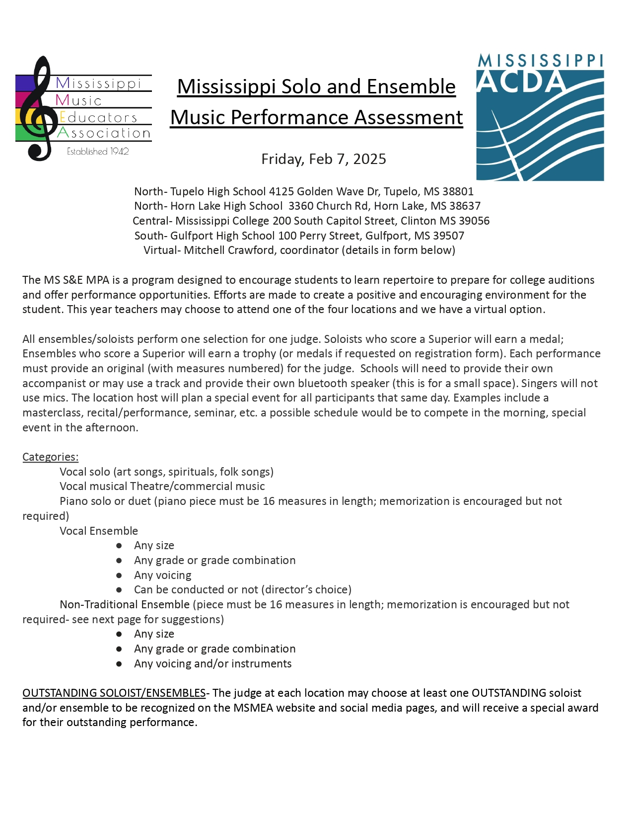

19
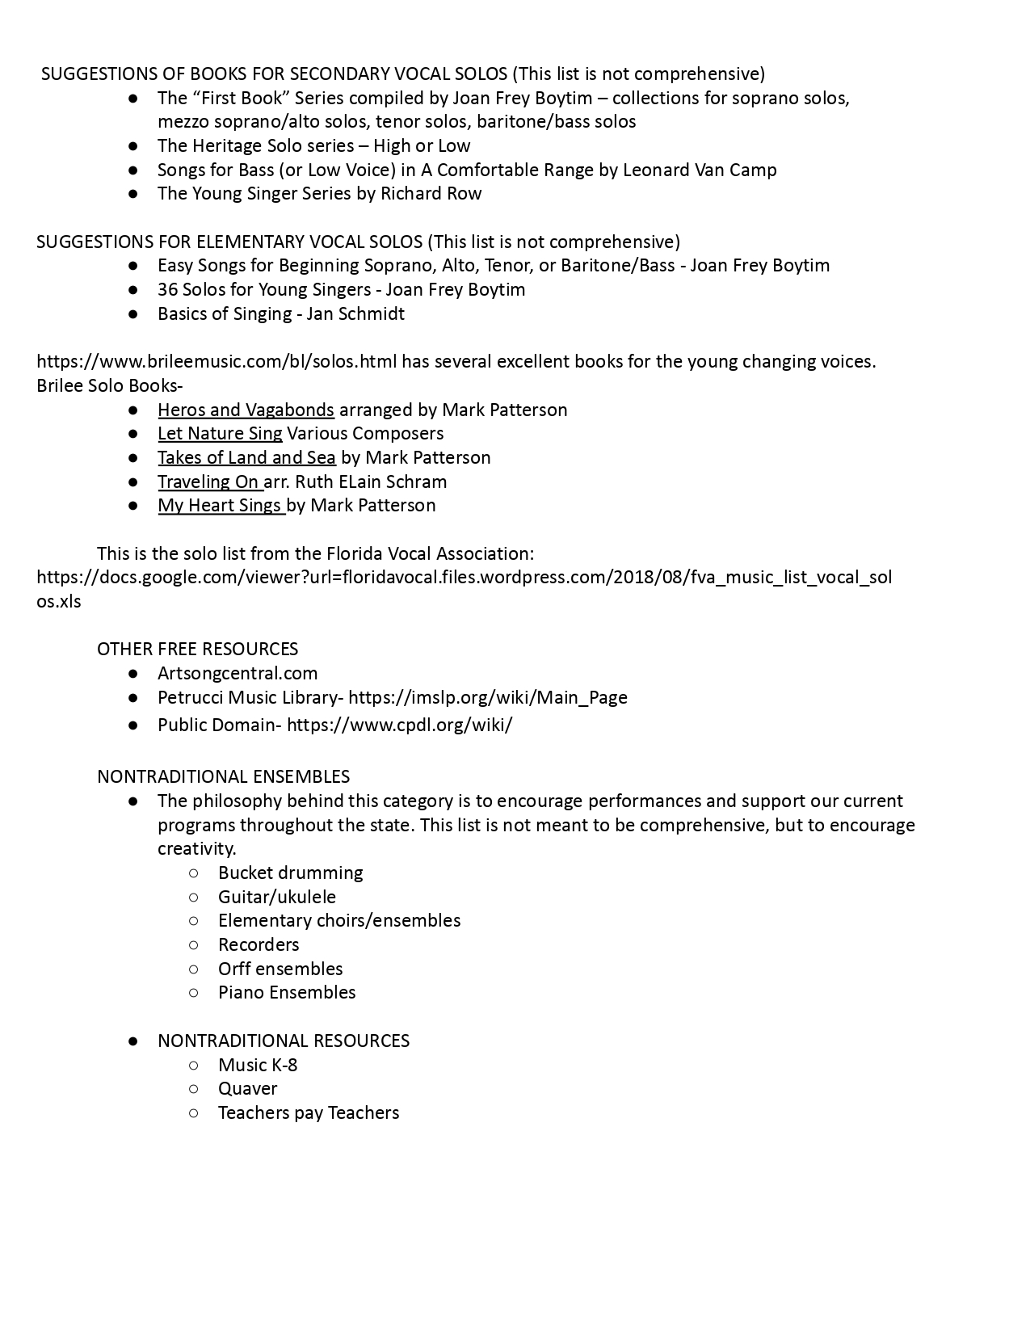20
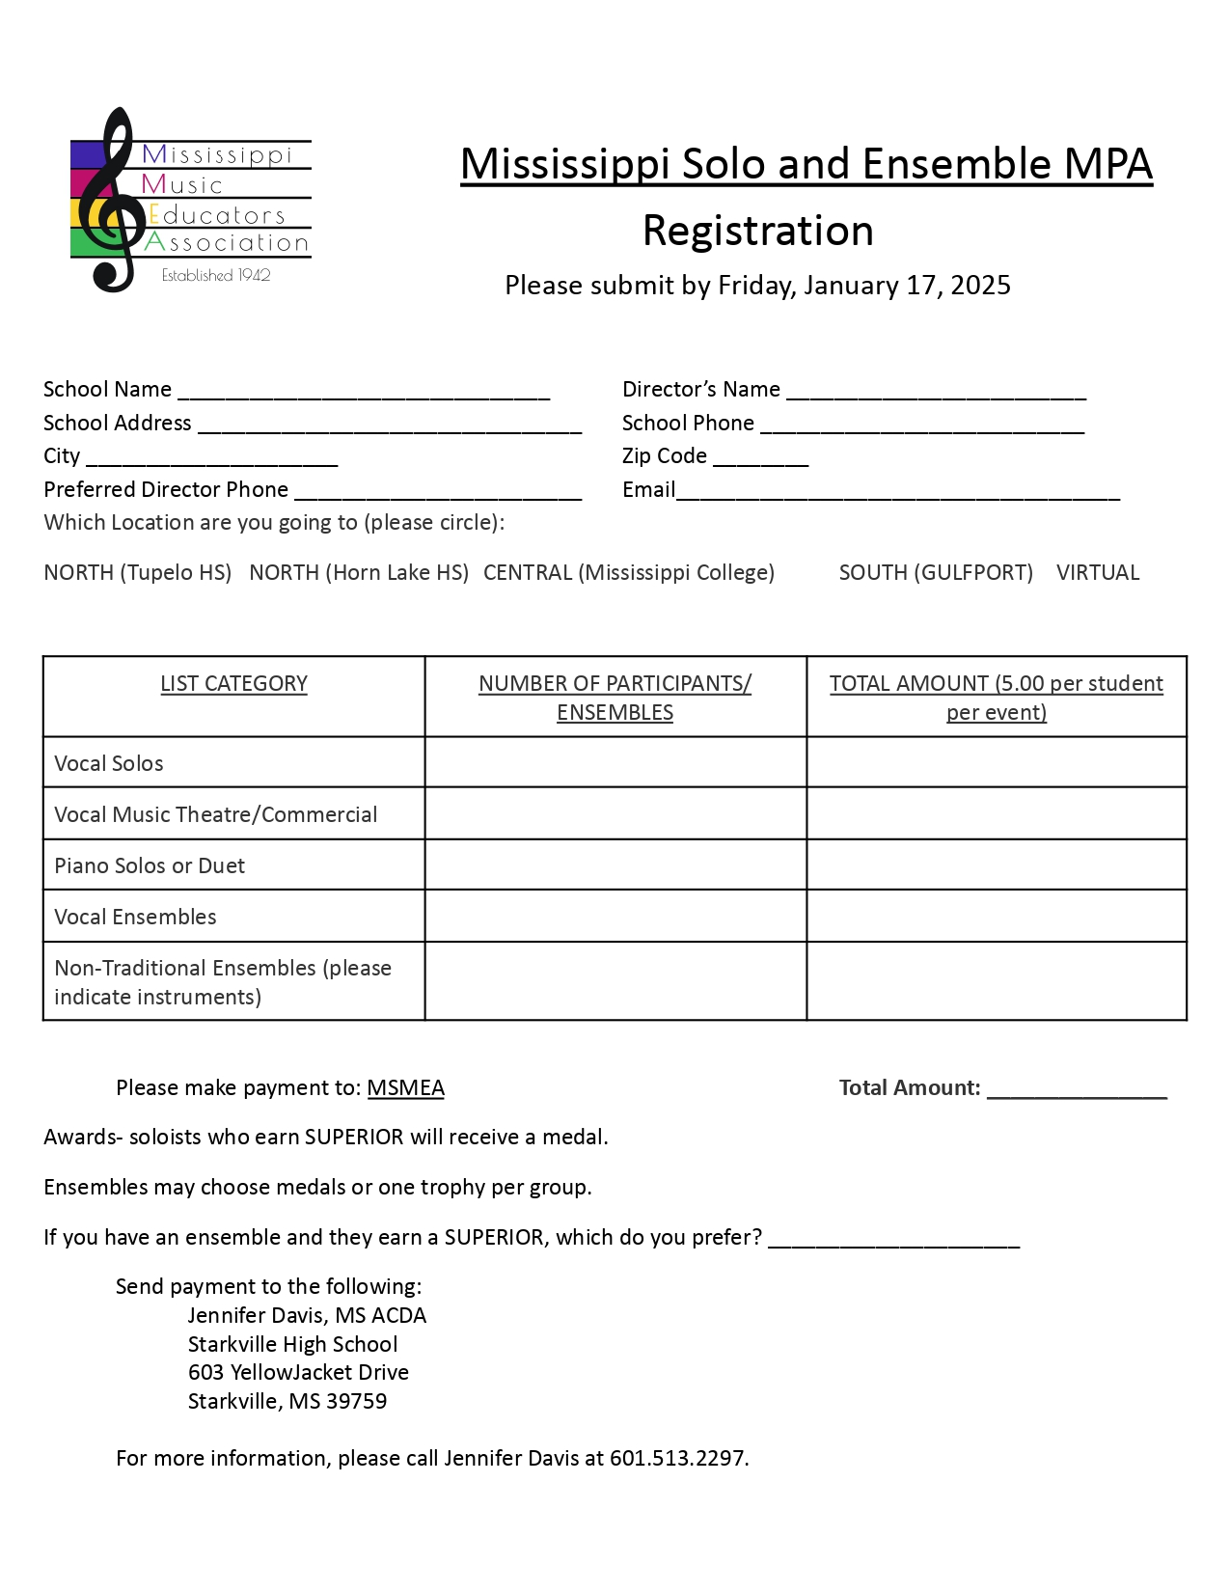
21
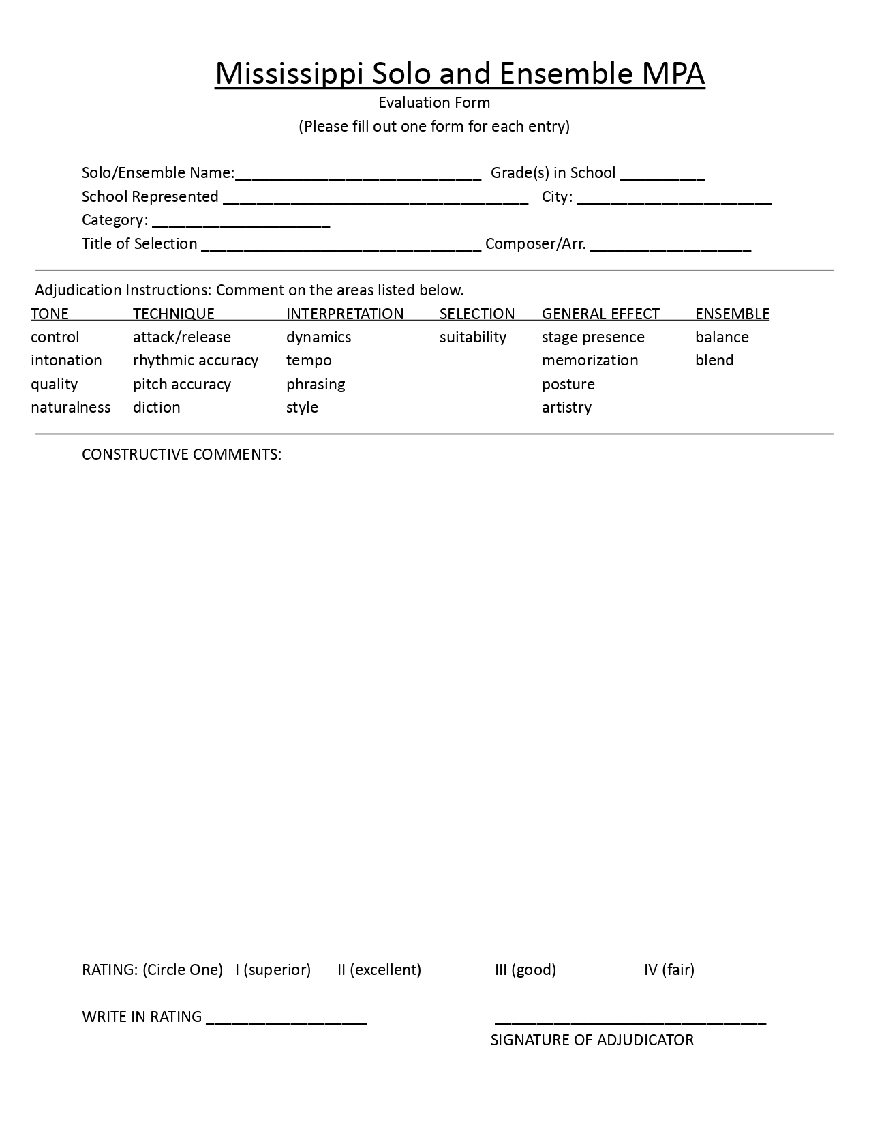
22
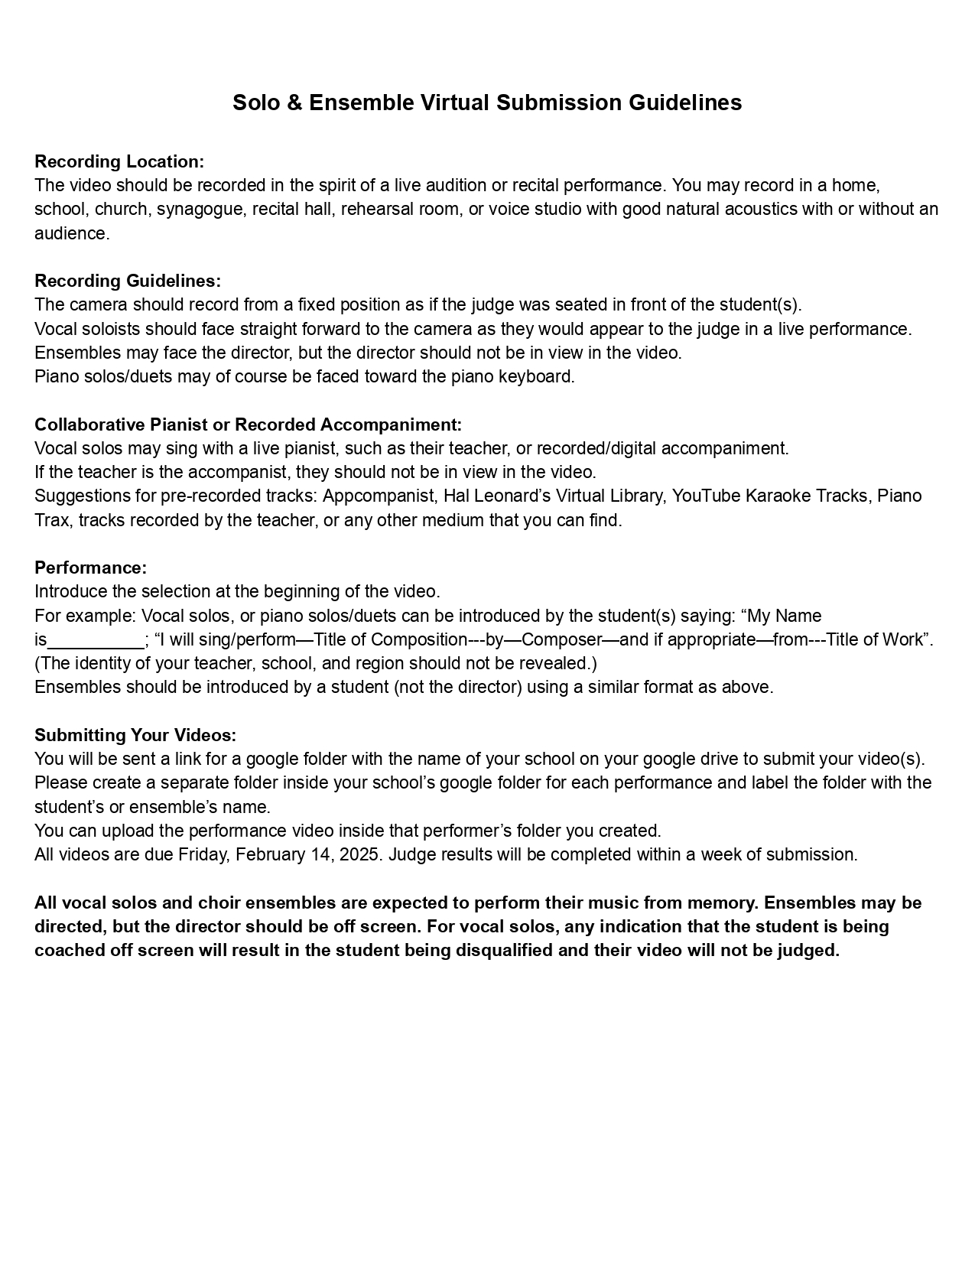
23

RECOMMENDATIONS OF BOOKS FOR JUNIOR HIGH SOLOS
1. Songs from World of Music books (grade 7 and 8) or any 7th/8th series
2. The “First Book” Series compiled by Joan Frey Boytim – collections for soprano solos, mezzo soprano/alto solos, tenor solos, baritone/bass solos
3. Sensational Songs for Solo Voice by John Leavitt Med-high/Med-low 4. The Heritage Solo series – High or Low
5. Songs for Bass in A Comfortable Range by Leonard Van Camp
6. Songs for Youthful Tenors of All Ages by Leonard Van Camp
7. The Young Singer Series by Richard Row
8. Heros and Vagabonds arranged by Mark Patterson (great for boys’ changing voices)
24
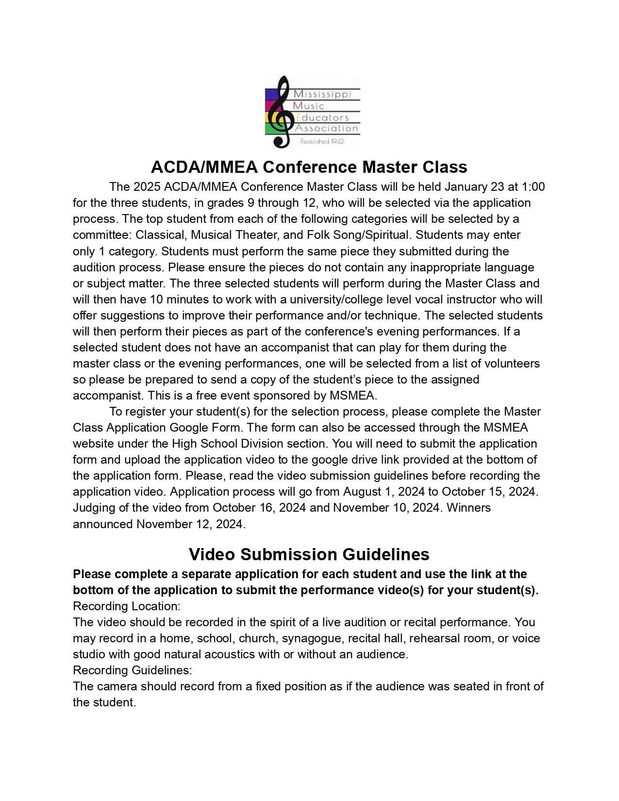
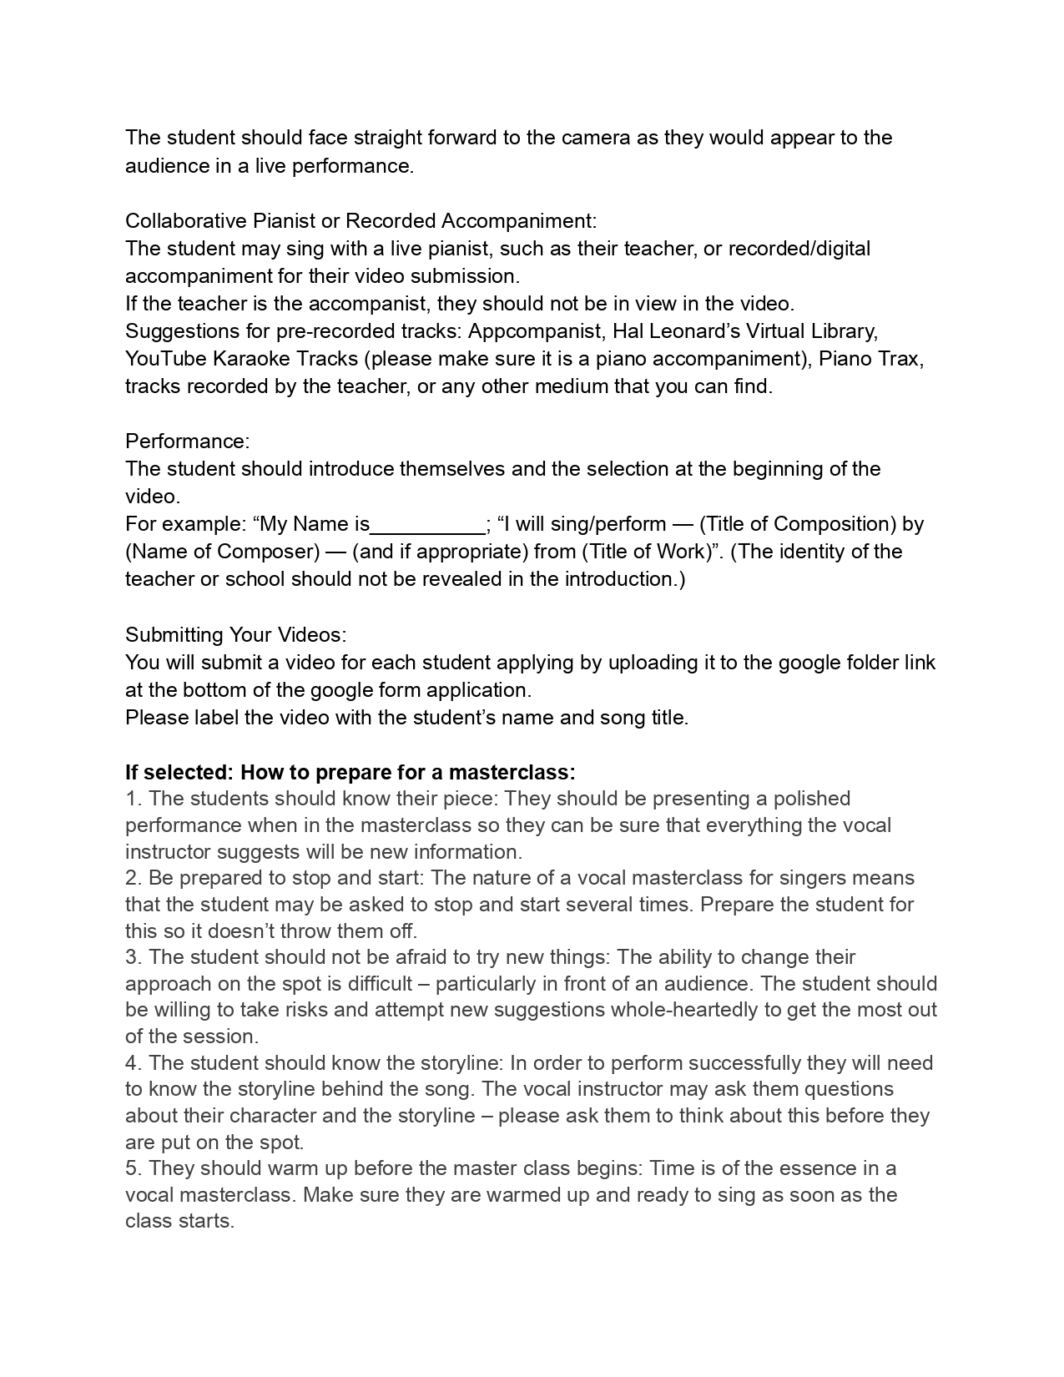

STATE
PERFORMANCE ASSESSMENT

27

ADJUDICATION
1. GENERAL FACTS –
a. Each group will perform two selections.
b. A director does not have to be a member of MMEA to participate in State Performance Assessment. His/her school, however, must be a member of MHSAA, and the director himself/herself must be registered with MHSAA.
c. All groups perform from memory.
d. Trophies are awarded to superior rated choirs, ensembles, and sight-reading.
e. Boys with unchanged voices may sing in a treble choir or ensemble.
f. Boys with changing voices may sing a note or short phrase up or down an octave to accommodate their range, within reason. Please indicate this on your score.
g. Music listed as 2-part may be sung with any combination of voicings (SB, ST, TB, etc.). Music listed as SA or TB must be performed as indicated (soprano/alto or tenor/bass) at the written pitch.
h. Time allotted for performance includes entering and exiting the performance area.
i. At festivals, choirs have a designated warm-up room, ensembles do not.
j. Ensemble absences: If an emergency or illness keeps an ensemble member from performing with its group at State Festival, the director has three choices:
i. Let the group perform without its usual number for either a rating or comments only.
ii. Substitute the absent student with another student.
iii. Scratch the group from the schedule.
k. There will be a $25 late fee if the registration form and fee is not received by the deadline.
l. Directors must provide adequate chaperones to help supervise students.
m. Groups who arrive at the festival late will be rescheduled after the last choir in the morning or the last choir in the afternoon. Any other situation will be determined by the chairman.
n. State Festival fees are $6.00 per student per event with a maximum of $400 per type of group and no maximum per school. State Festival fees for ensembles are $6 per person per event, with a minimum of $50 per ensemble. Any choir with fewer than twenty-one members will be charged as an ensemble. District Festival fees vary and are established by each district.
o. Duplication of students in choirs in the same voice category is not allowed. Duplication of students in ensembles in the same voice category is not allowed. For example, a singer may sing in only one Mixed Choir and only one Mixed Ensemble.
p. Choirs are considered to have twenty-one members or more. Ensembles have twenty members or less. Ensembles may be conducted.
q. A school may not enter more than one category with the same literature.
r. A school may not sing any same song in two consecutive years.
s. Recorded accompaniments are not allowed.
t. Special scheduling requests should be made on the registration form. Traveling distances will be considered for scheduling.
28

u. Fifth grade students are not eligible to participate in MMEA Festivals due to lack of insurance by MHSAA.
v. Sixth grade students may no longer participate in MHSAA sponsored events. However, they are eligible to participate in MMEA events such as: State Performance Assessment, Solo & Ensemble, and All-State Honor Choir. In such cases, catastrophic insurance coverage by MHSAA is unavailable. This is to be noted as a school field trip.
w. Photocopied music is not permitted unless it is accompanied by a current letter from the publisher or copyright holder granting permission to copy and stating that the appropriate fees, if any, have been paid.
x. There are no prescribed lists for festival; however, pop and patriotic music should be avoided. For helpful lists of graded literature, see the Florida Vocal Association’s prescribed lists at www.fva.net/mpa/muisc-list/ or the University Interscholastic League (Texas) at www.utexas.edu/uil/pml/browse.
y. Director must provide 3 original copies of the repertoire with all measures numbered.
2. VOICE CATEGORIES
a. Choirs must sing two selections
i. Boy Choir (unison, TB, TTB, TBB, TTBB)
ii. Treble Choir (unison, SA, SSA, SSAA)
iii. Mixed Choir (unison, SB(T), SAB, SATB)
b. Ensembles must sing two selections
i. Boy Ensemble (unison, TB, TTB, TBB, TTBB)
ii. Treble Ensemble (unison, SA, SSA, SSAA)
iii. Mixed Ensemble (unison, SB(T), SAB, SATB)
3. FEES AND FORMS
a. Read each registration form carefully for the following information:
i. Cost per student per performance. State Festival fees are $6.00 per student per event with a$400 maximum per type of group and no
maximum per school.)
ii. Who to make the check payable to
iii. Registration is due date (There will be a $25 late fee if the registration form and fee is not received by the deadline)
iv. Where to send the fees and forms
4. SWEEPSTAKES
a. Sweepstakes is defined as superior ratings from all three judges and sight reading at State Festival. Sight-reading must be the voicing sung on stage or one voicing down in order to be eligible for sweepstakes.
29
Sight Reading
1. General Information
a. All students who enter an adjudication category at State Festival must sight read at that same festival. Some directors will combine all singers into one choir to sight read, however directors may choose to divide students by choirs provided there is adequate time in the schedule. If a school enters only ensembles, then those ensembles will sight-read together.
b. All students who participate in State Festival will sight read.
c. The sight-reading example will be eight measures long and written in unison, two-part, three-part or four-part harmony. The director may choose the level to be read. It includes both melodic and rhythmic exercises. The two-part arrangement will accommodate SA, TB and SB reading and the four-part will accommodate SATB reading.
d. Numbers, words, solfege or neutral syllables may be used when sight-reading.
e. The same sight-reading selection will be used statewide.
f. There is only one sight reading judge, not three as in concert adjudication.
g. A suggestion is to begin teaching sight-reading the first day of school.
2. Procedure for Sight Reading Adjudication
a. The choir enters the room quietly and the director arranges students with the least amount of confusion possible.
b. The director will specify the voicing and the judge will pass out the appropriate selection. Each student should receive a copy along with the director and accompanist.
c. Each school must provide its own accompanist.
d. Teacher may change key of sight-reading material as appropriate.
e. The group has eight minutes to study the music including a run through with the accompaniment. The director may use any or all of the eight minutes to prepare both the melodic and rhythmic portions.
f. During the eight minutes of time you may:
i. Receive the keynote from the piano and have the choir sing the scale and I-IV-V7-I cadence in blocked chords or arpeggios without accompaniment.
ii. Point out key and time signatures, difficult rhythms, difficult intervals or any other markings in the music.
iii. The choir may speak, clap or tap rhythms.
iv. The choir may say the syllables, solfege, or numbers in rhythm.
v. The choir may work in groups on each part.
vi. The choir may ask and answer questions.
g. No one in the room may sing or hum the sight-reading material during this time until the director is ready for the students to sight-read.
h. At the end of the eight minutes, the director is prohibited from giving any further verbal instructions during the sight-reading performance. Violations will result in the lowering of the score.
i. Starting pitches are given and the students will sight read the selection with the piano on solfege, numbers, or whatever other method they use without stopping.
j. Teacher may keep a steady beat while students sing and may accompany the choir on their first run-through of the melodic passage.
k. The piece is to be sung a second time, a-cappella, without stopping.

30
l. If it is necessary for the director or judge to stop the choir during the singing of the piece, pitches may be obtained and singing will resume from that point. This will result in the lowering of the score.
m. The judge collects all copies of the music and dismisses the students. No music is to leave the room and the students are to leave quietly.
Mississippi Choral Sight-Reading Guidelines
A tiered sight-reading program is to be employed for each voicing.
Each sight-reading exercise will include three portions:
1. An eight-measure melodic passage that will count for 60% of the score.
2. An eight-measure rhythm passage that will count for 30% of the score.
3. The final 10% will be on work ethic.
Melodic Patterns
• Level 1
o Voicing: Unison
o Step-wise motion only
o Notes: Whole, Half and Quarter Note
o Rests: None
o Written in the Key of C Major
o Pitches: Do, Re, Mi, Fa, Sol
o 4/4 meter only
o No pickup notes
o Director may transpose into whatever key is needed by the choir.
• Level 2
o Voicing: Unison
o Step-wise motion, with skips in the Tonic Chord
o Notes: Whole, Half, Quarter and Eighth
o Rests: Half, Quarter
o Written in the Key of C Major
o Pitches: Do, Re, Mi, Fa, Sol, La
o 4/4 Meter Only
o No pickup notes
o Director may transpose into whatever key is needed by the choir.
• Level 3
o Voicing: 2-part homophonic
o Step-wise motion, with leaps of Do to So or So to Do
o Notes: Whole, Dotted Half, Half, Quarter and Eighth
o Rests: Same as level 2
o Written in Key of C or G Major
o Pitches, Do, Re, Mi, Fa, Sol, La, Ti, Do (Octave)
o 4/4 or 3/4 meter
o No pickup notes
o Director may transpose into whatever key is needed by the choir.
31
• Level 4
o Voicing: 3 part & 4 part Homophonic
o Step-wise motion, with leaps of Do to Fa and some diatonic passing tones. o Notes: Whole, Dotted Half, Half, Dotted Quarter/Eighth, Quarter and Eighth o Rests: Same as Level 2
o Written in Key of C, G, or F Major
o Pitches: Do, Re, Mi, Fa, Sol, La, Ti, Do (Octave)
o 4/4 or 3/4 meter
o No pickup notes.
o Director may transpose into whatever key is needed by the choir.
Rhythm Patterns
• Level 1
o 4/4 meter
o Notes: Whole, Half, Quarter
o Rests: Whole, Half, Quarter
• Level 2
o 4/4 and 3/4 meter
o Notes: add Dotted Half and 2 Eighth notes (grouped)
o Rests: Same as level 1
• Level 3
o 4/4 and 3/4 meter
o Notes: add Dotted Quarter and single Eighth note
o Rests: Same as level 2
• Level 4
o 4/4 and 3/4 meter
o Notes: add Group of 4 Sixteenth notes and Eight/Quarter/Eighth syncopation
32
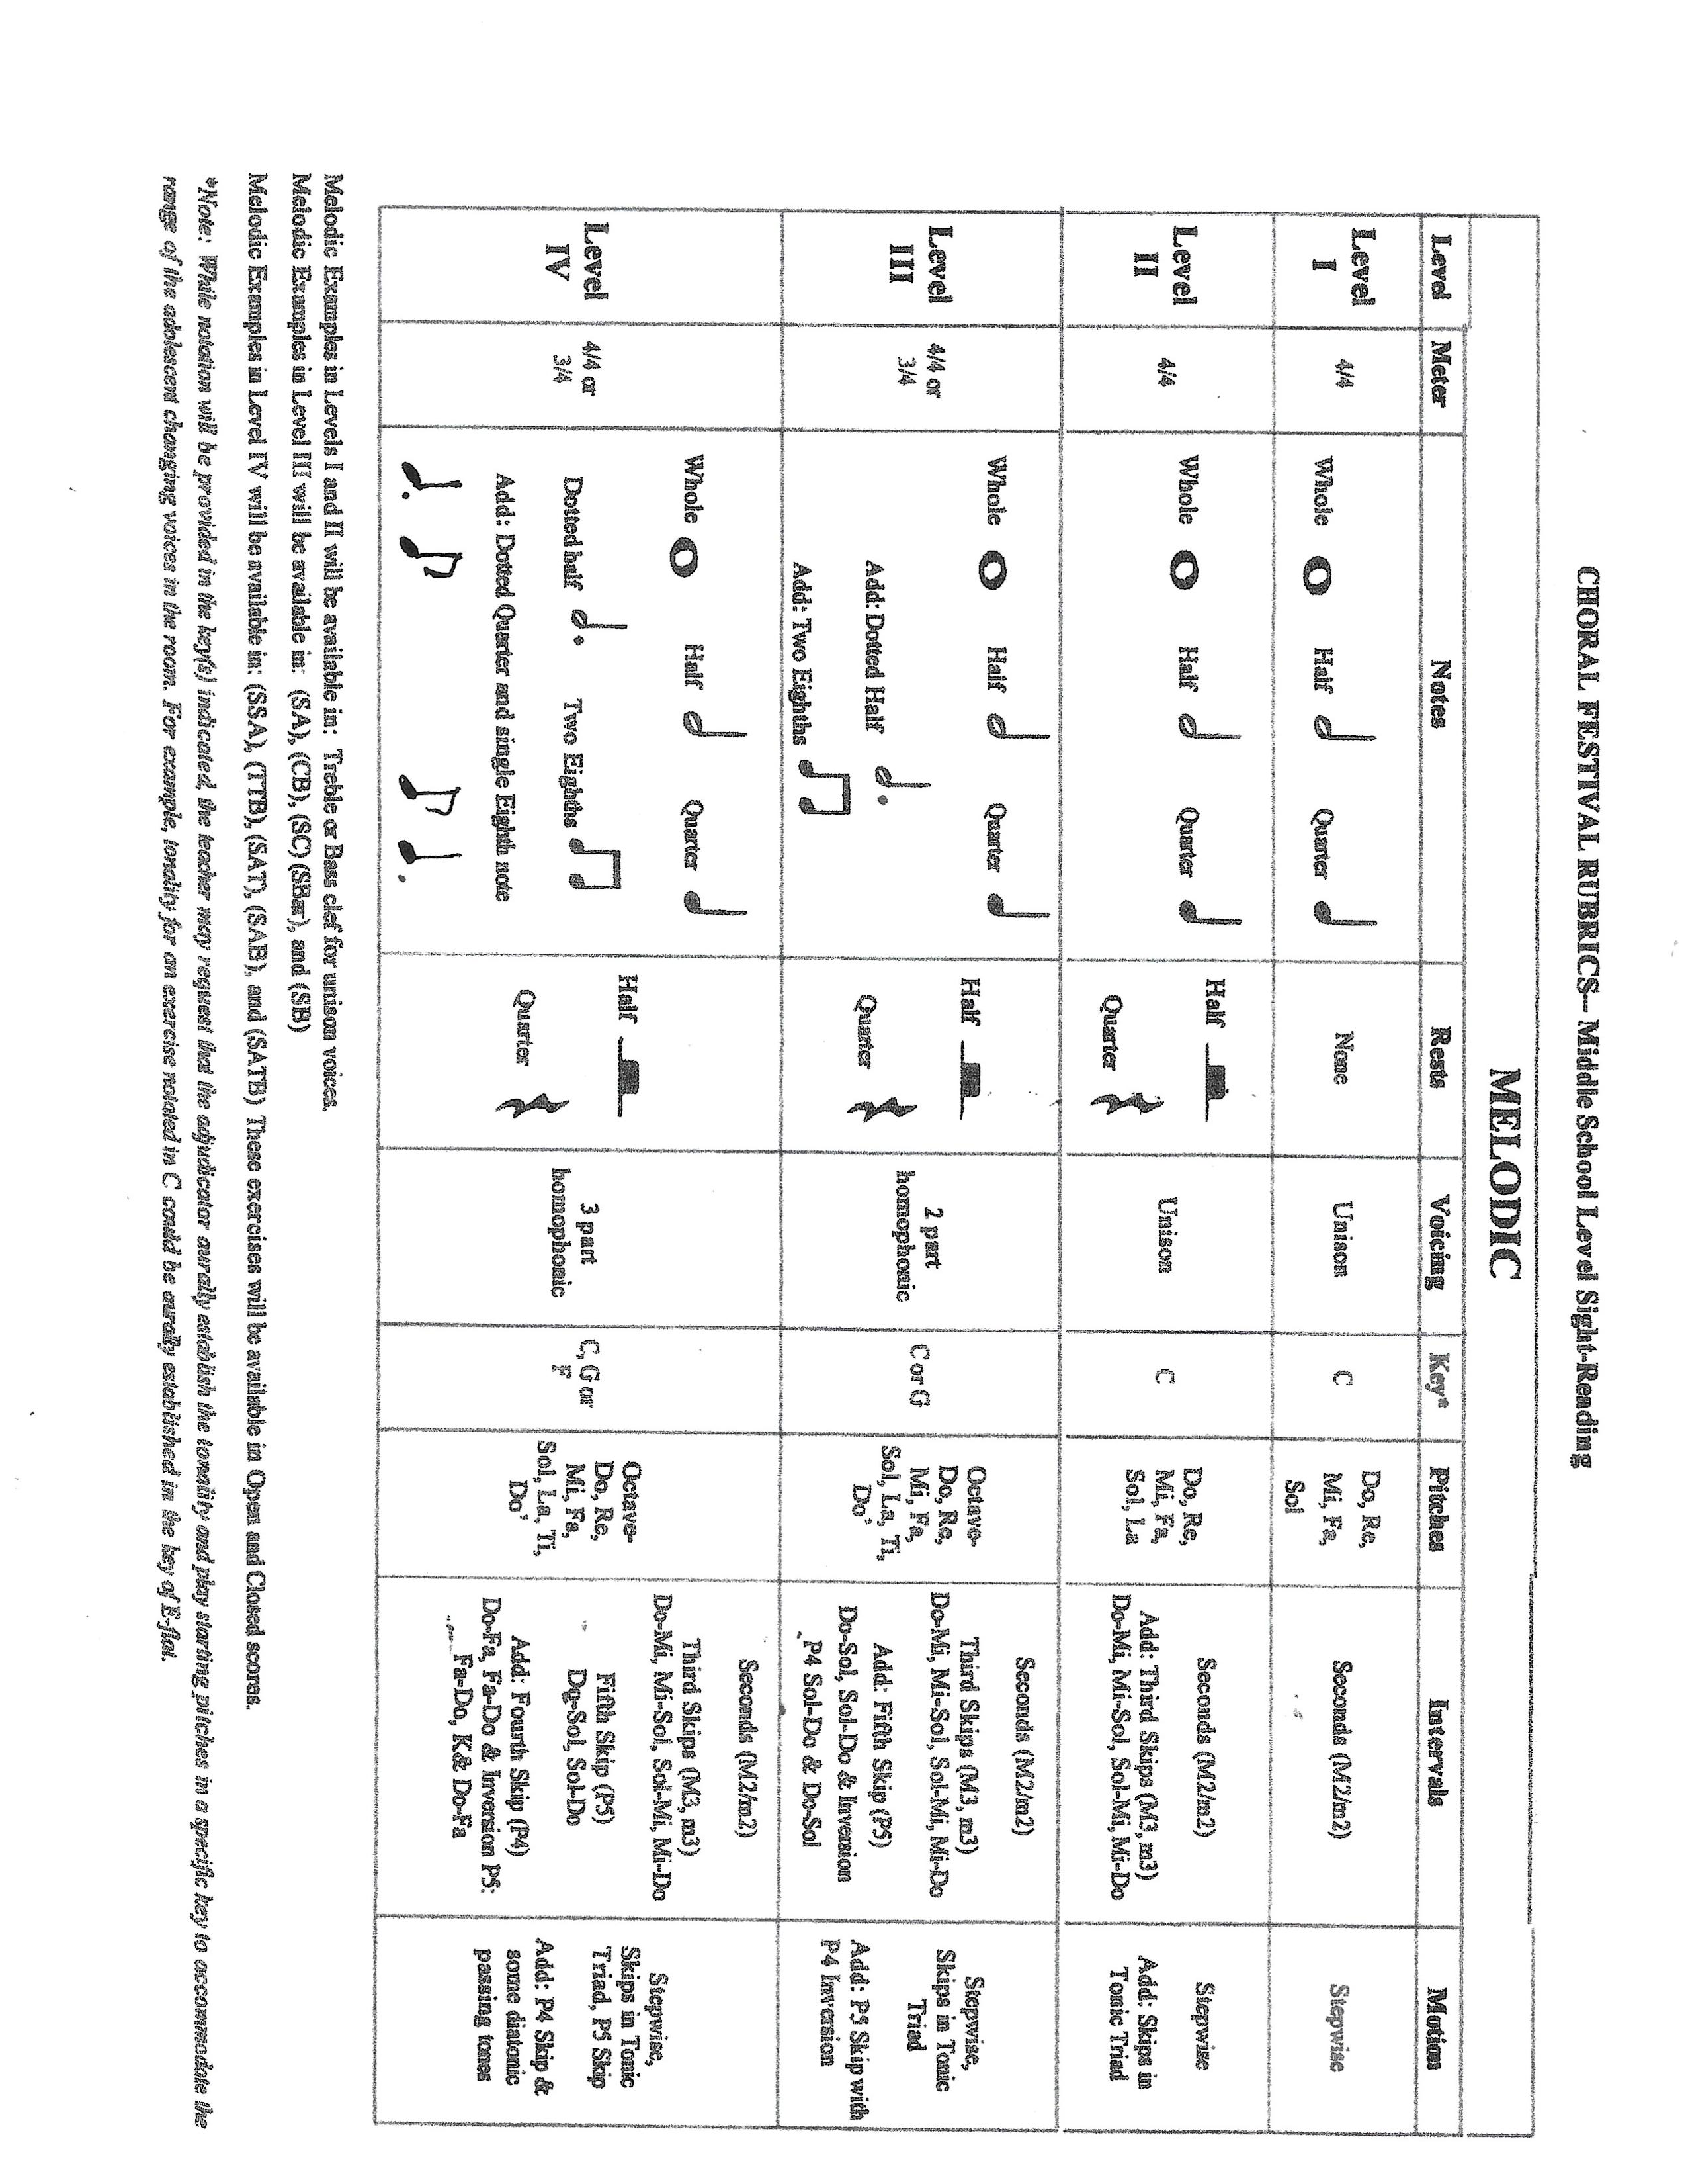
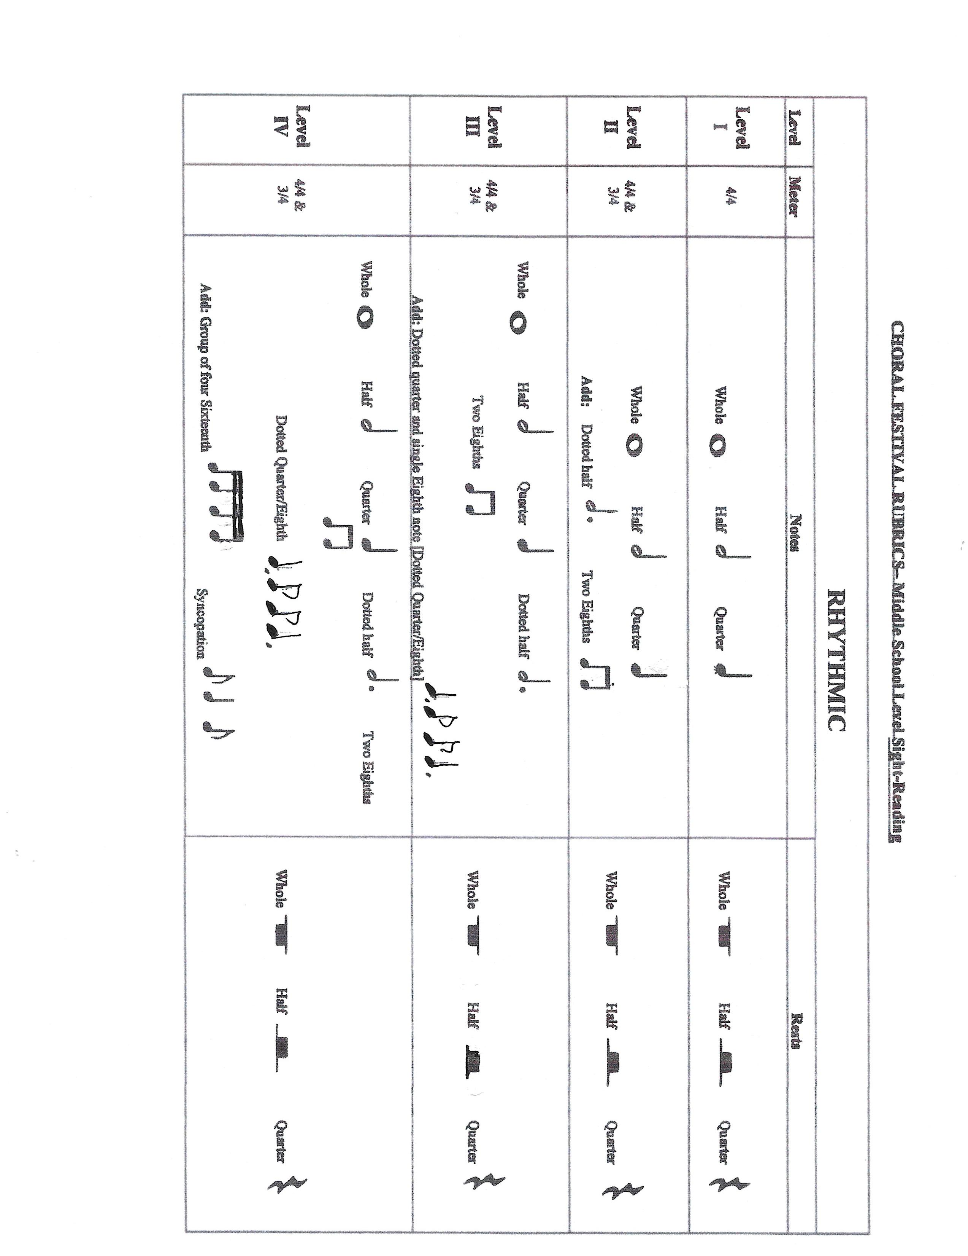
State Performance Assessment Registration
Due to JH State President by Friday, January 17, 2025
with Check Payment or Purchase Order
School _____________________________________________ Region (circle one) NORTH | CENTRAL | SOUTH
Director ________________________Cell Phone: ______________Email: _________________________________
Approximate Travel from School to Festival (ONE WAY): Mileage____________ Travel Time _________________
Preferred Date to Attend_____ Preferred Time of Day____ Accompanist’s Name_____________________________
Incomplete forms or forms without payment will NOT be accepted or scheduled.
Type of Choir or Ensemble | # in Group | SELECTION AND COMPOSER/ARRANGER TO BE PERFORMED
 |  | 1.
 |  | 2.
 |  | 1.
 |  | 2.
 |  | 1.
 |  | 2.
 |  | 1.
 |  | 2.
 |  | 1.
 |  | 2.
 |  | 1.
 |  | 2.
 |  | 1.
 |  | 2.
 |  | 1.
 |  | 2.
 |  | Total # of Participants | FOR MMEA OFFICE ONLY  CK# Date  PO# Date  From  Amount  Date Deposited
 | X $5.00 | Fee per Participant Per Group
 |  | Total Cost for Participants
 | + $40.00 | Required Assessment Data Fee (Audio Recording)
Total Due |  | Amount Due: Payable to MMEA (Prior to Event)

MS List: https://msmea.org/high-school-division/ TX List: https://www.uiltexas.org/pml/ FL List: https://fva.net/mpa/music-list/
1. Make payments payable to MMEA in the form of a CHECK or PURCHASE ORDER.
2. Email Form = to gingerpartain@gmail.com
3. Mail both Form and payment (postmarked by January 17, 2025) to the JH State President:
Ginger Partain: 720 W Jefferson St. Tupelo, MS 38804

Director’s Signature Date Principal’s Signature (REQUIRED) 35
INVOICE

Date:
To:

Remit to:
Attn: Ginger Partain
720 W Jefferson St. Tupelo, MS 38804
DESCRIPTION PRICE
Total

Checks should be made payable to MMEA and mailed to the address listed above.
Please contact Ginger Partain, Junior High State President,
with any questions.
Phone: 662-891-2327
Email: gingerpartain83@gmail.com

36

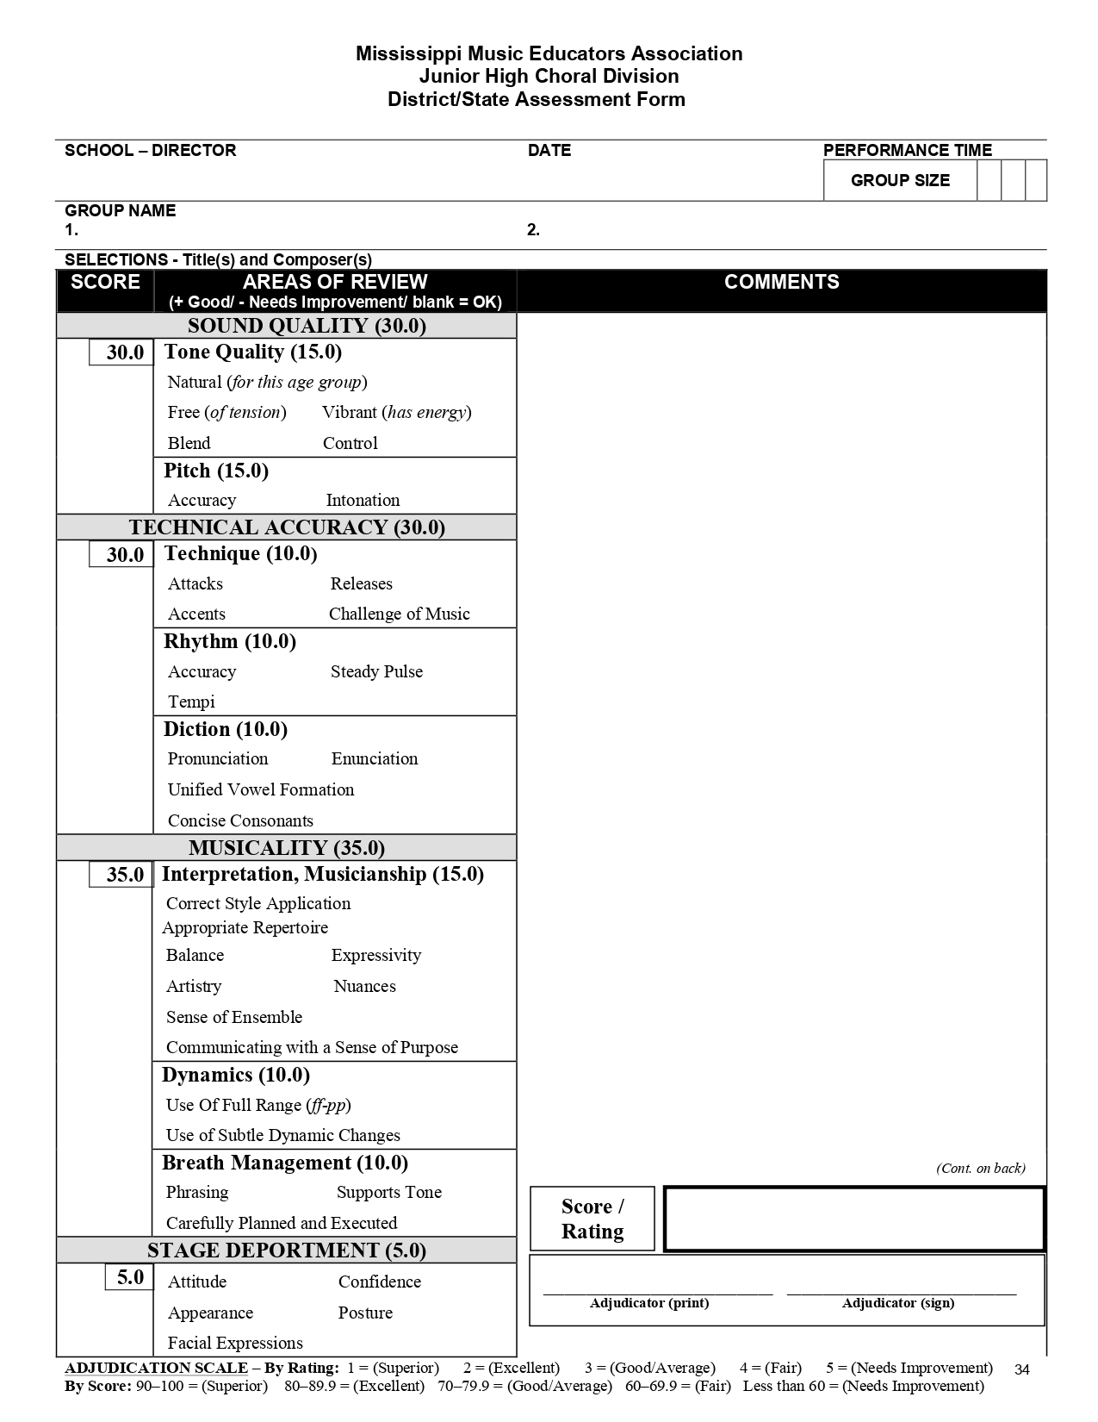
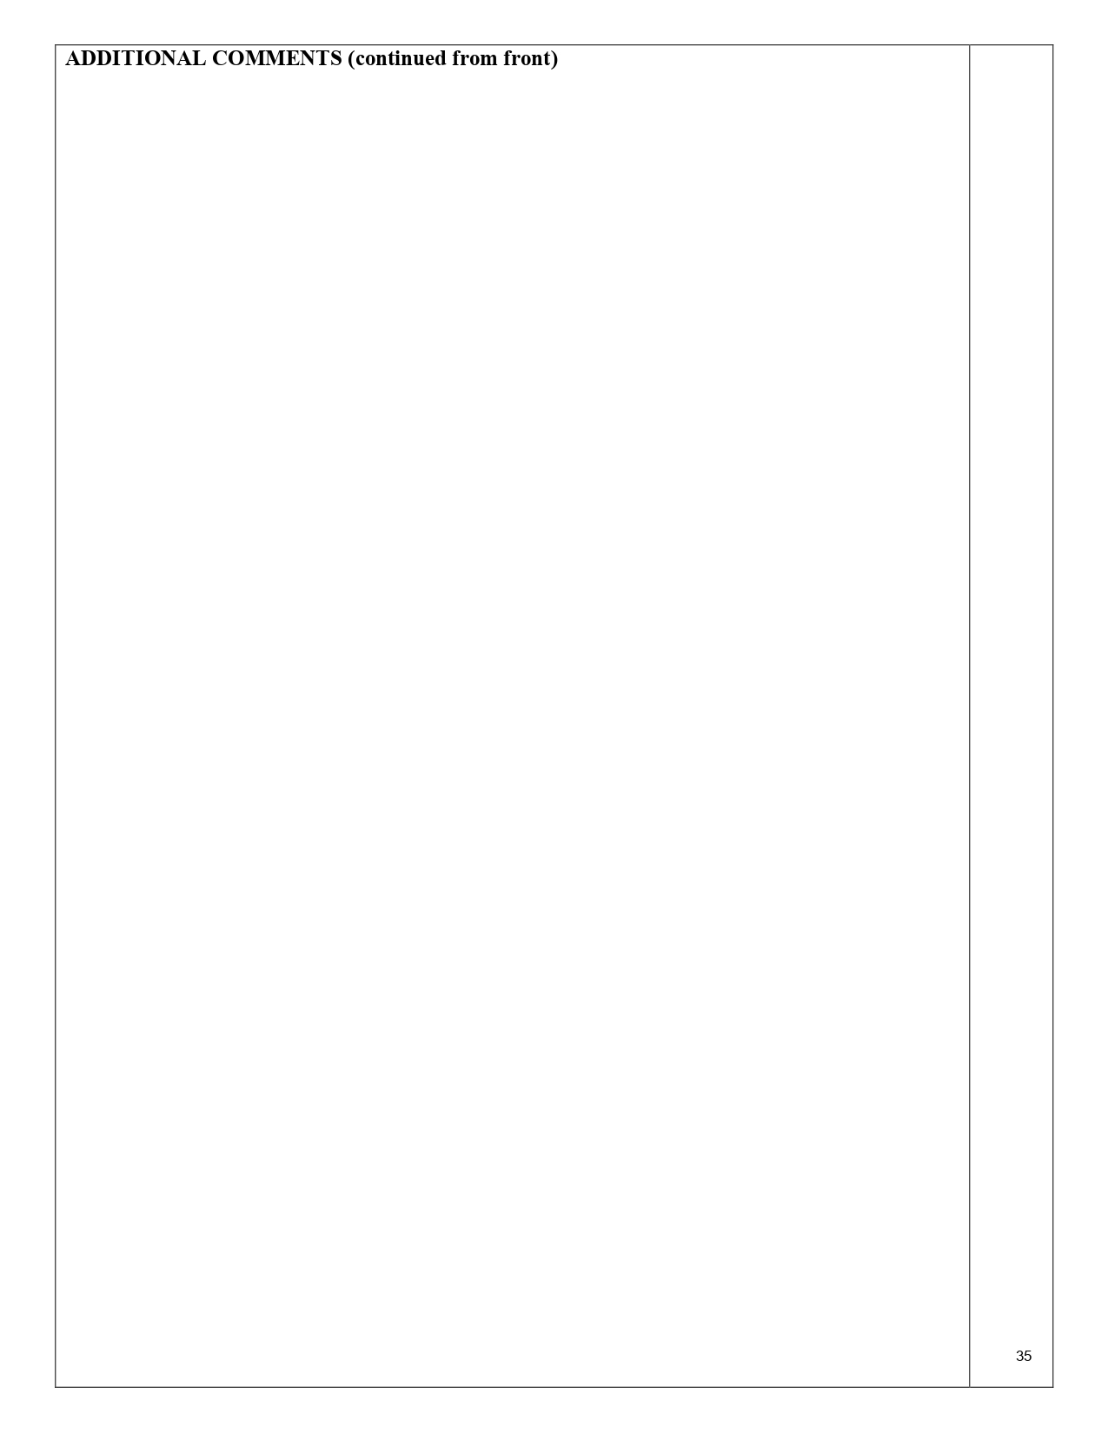
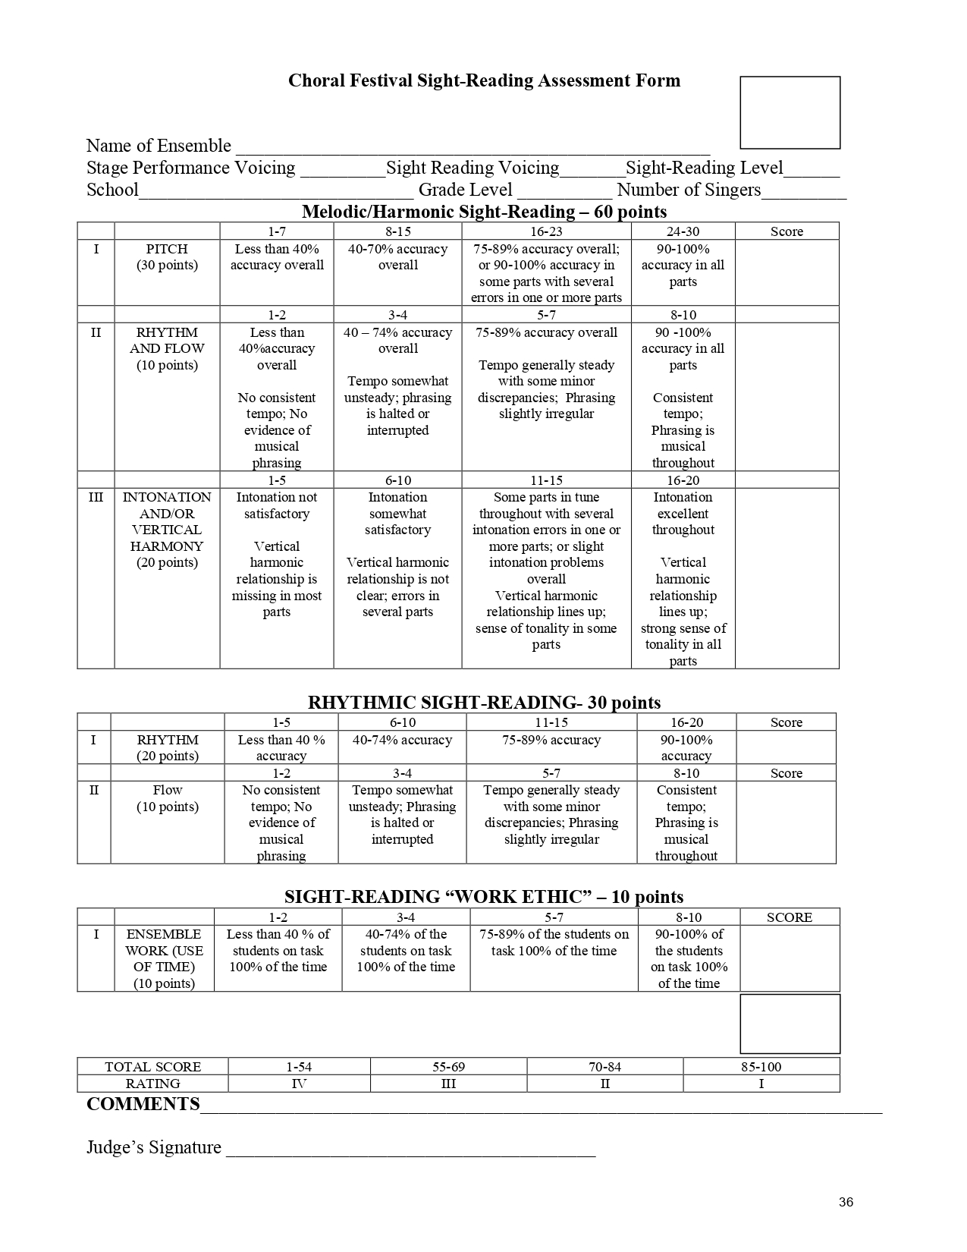


HONOR CHOIR
MMEA/ACDA
CONVENTION
41

JUNIOR HIGH ALL-STATE HONOR CHOIR

1. GENERAL INFORMATION
a. An enriching SATB/SSA choral experience for outstanding middle and junior high school vocal students, statewide, organized and governed by the President-elect of our organization and SSA Chairperson.
b. An annual event at which rehearsals and concerts take place in conjunction with the State MMEA/ACDA Convention held during the spring semester.
c. Approximately 250 students are chosen by audition to work with nationally recognized conductors.
d. Directors must be active members of NAfME to audition students for this honor choir.
e. Directors should audition their most outstanding and best-prepared singers. Please do not audition students “just for the experience."
f. The number of students each director is allowed to audition is as follows – Limit 10 soprano 1’s, Limit 10 soprano 2’s, Limit 10 altos, no limit for tenors or basses.
2. SPECIFIC INFORMATION
a. Detailed information concerning fees, audition sites, music, etc. is given at the fall business meeting. The forms are included in this section. The audition fee of $15 must be paid by the posted deadline either through Opus Event parent payment link or a check to MMEA Jr. High.
b. Auditions are held in September. See the Jr. High Division Calendar.
c. 9th graders are allowed to audition provided they are not auditioning for the high school honor choir.
3. AUDITION PROCESS
a. Students must learn two pieces statewide (ladies will learn one selection each from the SATB & SSA repertoire list). These are chosen by the conductor.
b. Each student will audition virtually on their part singing only the sections posted on www.msmea.org. NO PHOTOCOPIED MUSIC ALLOWED!
c. For a-cappella pieces, the voice parts will be played.
d. Please submit one copy of the Honor Choir Audition List Form via email to the Honor Choir chairman. Those auditioning should be categorized by voice part. They will be assigned a number by the system.
e. One adjudicator will judge treble voices (soprano, soprano 2, and alto), and one adjudicator will judge changed voices (tenor and bass). Adjudicators will hear each student and will submit comments and score virtually. If you would like the judge's comments sent to you, you will need to specify that on the Honor Choir Audition List Form. The Honor Choir chairman will e-mail the judge's comments to you upon request only.
f. With the addition and retention of the SSA choir, treble students (who earn a spot in the honor choir) will be divided evenly between the SATB and SSA honor choirs.
g. There is a mandatory fee of $15 per student to audition.
4. HONOR CHOIR WEEKEND
1. Students must be at all rehearsals and must be on time. Follow your schedule very carefully and always listen to directions in case there is a change.
2. Students must show proper behavior, posture, and attention. If not, their director will be notified. They will not be allowed to participate in the Honor Choir and no refund will be given.
3. Honor Choir participation fee is $75.00 per student.

42
Please send one check per school if not paying fees through Opus Event.

For the 2024-2025 school year, please send payment to:
MMEA
Attn: Dr. Lynn Holliman
Jr. High President-Elect
3515 Hwy. 1 South
Greenville, MS 38701
musicloverau2020@gmail.com

43
Mississippi Music Educators Association
Jr. High Honor Choir Registration Form
2024-2025
IMPORTANT REMINDER: Teacher MUST be a member of NAfME for his/her students to audition for the Jr. High State Honor Choir. The teacher also must be a member at the time of the convention and must be registered for the convention for the students to attend the rehearsals and performance. The membership rolls will be checked prior to auditions and again prior to the conference.
Director’s Name ________________________________NAfME #______________________
School Name ________________________________________________________________
School Address ______________________________ City _____________Zip Code _______
School Phone _________________________________
Home Address ______________________________ City _____________Zip Code _______
Home Phone _________________________Cell Phone___________________________
Email Address __________________________________________
Total number of students in performing choir(s):
Sopranos _______ Altos ______ Tenors_______ Bass_______
Estimate the number of students you wish to audition, staying within the given percentages:
Soprano 1 (Limit 10) ________ Soprano 2 (Limit 10) ________ Altos (Limit 10) ______
Tenors (No Limit) ________ Bass (No Limit) _______
Total ______ X $15 = $________ (If not paying through Opus Even, please send one check per school payable to MMEA Jr. High.)
Do you wish to receive the adjudicator comments for your students? _____Yes _____No

Registration Form Due September 4, 2024
Audition Window: September 4-20, 2024

*Also include a publicity release for each student who will be auditioning.

Mail fees and form to:
MMEA
Attn: Dr. Lynn Holliman
3515 Hwy. 1 South
Greenville, MS 38701
musicloverau2020@gmail.com 44

Photo/Video Release Form

AUTHORIZATION TO USE PHOTOGRAPHS AND/OR AUDIO-VISUAL

I, (parent's name)__________________________________________________, hereby authorize The MS Music Educators Association, MMEA, to use, reproduce, and/or publish photographs and/or video that may pertain to my child (child's name)____________________________________________________ including his/her image, likeness and/or voice without compensation.

I understand that this material may be used in various publications, public affairs releases, recruitment materials, broadcast public service advertising (PSAs) or for other related endeavors. This material may also appear on the MS Music Educators Association Internet Web Page.

This authorization is continuous and may only be withdrawn by my (parent) specific rescission of this authorization. Consequently, MMEA may publish materials, use my child's name, photograph, and/or refer to my child in any manner that MMEA deems appropriate to promote/publicize service opportunities.

________________________________________________________________
Signature of Parent

________________________________________________________________
Print Child's Name

_____________________________________________________________
Date

Teacher Name ____________________________________________________

School__________________________________________________________

(Directors - upload this form to Opus Events when completing student applications. Please do not mail in to Dr. Lynn Holliman.)

45

3
MMEA/ACDA STATE CONVENTION
1. General Information
a. A three-day annual event co-sponsored by the executive boards and membership of MMEA and MSACDA.
b. Features include –
i. Exhibits by companies in fundraising, sheet music, travel opportunities, college and universities, etc.
ii. Performance hours, luncheons, general sessions, workshops, meetings by divisions, etc.
iii. Performances by the following honor groups;
MMEA Elementary Honor Choir
MMEA Junior High Honor Choirs – SATB, SSA
ACDA All State High School Mixed Honor Choir
ACDA All State High School Show Choir
ACDA Treble Honor Choir
The opportunity to study with and/or observe nationally acclaimed
musicians as they conduct workshops and rehearsals
2. Procedure for Performing at Convention
a. Submit a recording by the deadline listed on the calendar – this recording must be a high quality recording of two selections, one from the previous year and one from either the current year or two years before
b. Submit with the tape a planned program of performance
c. For more information contact your State Chairman
46

MENTOR
PROGRAM
47

MENTOR PROGRAM
The purpose of the mentor program is for experienced teacher to help less experienced teacher get their feet on the ground. To be a mentor you must meet the following requirements:
1. Have at least five years teaching experience
2. Be willing to remain in contact with your “mentee” and guide them through the yearly activities
3. Be willing to go to the “mentee’s” school at least twice a year and give hands-on assistance
4. Do not discuss the “mentee’s” issues with other people. You may, however, ask advice for varying situations.
5. Make sure your “mentee” understands all handbook information 6. Be willing to suggest appropriate literature for choral performance 7. Offer beneficial information about festival preparation
8. Offer sight reading tips
9. Encourage membership in professional organizations
The responsibility of the “mentee” is to sign-up for a mentor and then to ask them questions. You must also be willing to get involved. This is a chance for the “mentee” to build a quality choral music program.
48
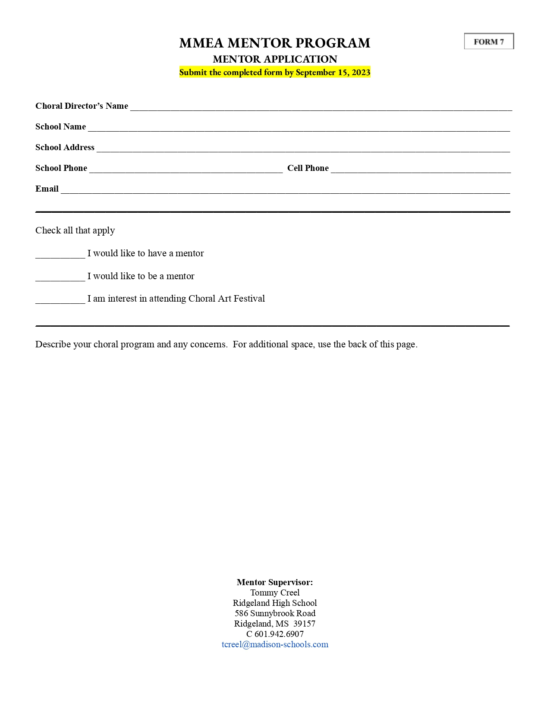


2024-2025

MHSAA / MMEA
CHORAL ART FESTIVAL

Choral Art Festival Coordinator

MHSAA / MMEA Choral Art Festival
April 10-11, 2025
Location: Pearl High School
Daniel Vernon, MMEA Senior High Choral
Division President Elect
Gulfport High School
270 Oakwood Drive
Gulfport, MS 39507
C 601.218.4631
daniel.vernon@gulfportschools.org

50
General Information
- MMEA is responsible for the Choral Art Festival and will continue to offer it as an alternative to the State Performance Assessment for the choice of Ratings or Comments Only.
- The purpose of this festival is to provide new and developing choral programs, grades 7th-12th, and choral directors with a positive, non-threatening, non-competitive choral experience that will ultimately lead to their participation in the State Performance Assessment.
- Participation in one MHSAA sanctioned event (SPA or CAF) is required of all MHSAA member schools with choral programs. Choral groups may NOT participate in both MHSAA sanctioned festival events; they must choose the Choral Art Festival or the State Performance Assessment.
  - a choral director who wishes to request exemption from the Choral Art Festival must submit an Exemption Request Letter along with FORM 1 to the MHSAA Office by September 15
  - request letters must be composed on school letterhead by the requesting choral director’s principal
- To participate in the Choral Art Festival:
  - a choral director’s school must be an employee of an MHSAA member school
  - a choral director must be registered with MHSAA (FORM 1)
  - choral students and small ensemble students must be recognized by school authorities and meet MHSAA eligibility requirements (DragonFly Max)
  - a choral director is not required to be a member of MMEA or NAfME
  - a choral director must complete an approval application (FORM 8) and submit it to the Choral Art Festival Site Coordinator by December 01 (see the form)
- MHSAA only provides catastrophic insurance for 7th – 12th graders.
  - Therefore:
    - there are no restrictions on performance combinations for 7th - 12th grade participants
      - 7th – 12th grade choral groups must make checks payable to MHSAA
- The choral director may choose numeric Ratings OR Comments Only for BOTH the stage performance portion and the sight-reading portion of the festival.
  - regardless of a choral director’s choice, each choral group will receive a 10 – 20-minute on-stage clinic following their stage performance
    - the on-stage clinic is provided by one of the three stage performance adjudicators / clinicians
    - instruction and comments will be constructive and student-centered
  - choral groups who opt for Comments Only for sight-reading will spend the allotted time working with the sight-reading clinician
    - the clinician will focus on teaching effective practices and techniques to help the choral groups better understand the expectations of the adjudication process
    - the overall goal of the sight-reading clinician will be to build the students’ confidence and set each choral group on a path to successful music reading and development
- A choral director who is feeling overwhelmed should immediately begin communicating with the Choral Art Festival Site Coordinator (current President Elect).

Registration Forms and Fees
- Choral Art Festival registration fees are set by MMEA.
  - registration fees are $5.00 per student, per adjudicated group. Example: The total registration cost for a student who sings in an SATB Choir, SSA Choir, & Sextet is $15.00.
- Participation in the Choral Art Festival is by approval application only (FORM 8).
  - applications are open to all choirs and ensembles based on the specifications listed on FORM 8
  - the CAF Coordinator will contact each choral director regarding their approval status
- Following the approval process of FORM 8, registration forms (FORM 9 & 9B) and fees (copy of P.O.) are due to the CAF Coordinator by the Winter Business Meeting. Be diligent.
  - registration fees are non-refundable
  - registration fees must be paid in full prior to the festival
  - registration fees for additional students not listed on the original registration form must be paid in full prior to the festival event
- Schools will not be placed on the performance schedule until completed registration forms and registration fees have been received by the CAF Coordinator.

Music Requirements
- Choral groups should perform two selections from memory, chosen by the choral director. There are no prescribed list requirements for the festival; however, pop, and patriotic music should be avoided. For helpful lists of graded literature, see the following prescribed lists:
  - Florida Prescribed List (FPL) https://fva.net/mpa/music-list/
  - Texas Prescribed List (TPL) https://www.uiltexas.org/pml/
  - Mississippi Prescribed Music List (MPS) https://msmea.org/high-school-division/ms-prescribed-music-list-2/

51

Choral Art Festival Expectations
- Each school must arrive at CAF 30 minutes prior to their first scheduled event.
- Envelope preparation for the day of CAF
  - the choral director must provide the stage performance adjudicators with (3) original copies of their performance repertoire, all measures numbered
  - the choral director must provide the stage performance adjudicators with (3) completed copies of FORM 10
  - the choral director must provide the stage performance adjudicators with (3) completed copies of FORM 11
  - the choral director must provide the sight-reading adjudicator/clinician with (1) completed copy of FORM 12
- All choral groups are encouraged to attend the stage performances of other choral groups and quietly observe the clinicians’ work throughout the day.
- No one will be permitted to enter or leave the adjudication area while a performance is in progress.
- Children under the age of 6 will not be allowed in the adjudication area. Please advise parents.
- Conduct: The choral director and principal of each school will be held responsible for the proper conduct of all persons representing their school. Begin teaching / training behavioral expectations early in the school year.

Assessment Ratings
- Adjudication of choirs and ensembles will be on a performance basis with ratings of
  - Superior (I)
  - Excellent (II)
  - Plus and minus signs will not be used
- For choral groups who choose Ratings for stage performance, each adjudicator will give a score & rating. For choral groups who choose Ratings for sight-reading, the adjudicator will give a score & rating.
- The tabulator (CAF Site Coordinator) assigns the appropriate composite score based on those ratings. See the chart below for possible composite scores.
- Certificates are awarded to choirs and ensembles for superior rated scores in stage performance and sight-reading.

ADJUDICATION SCALE BY RATING Superior = I Excellent = II
ADJUDICATION SCALE BY SCORE Superior = 85-100 Excellent = 75-84

Composite Rating | I | II
 | I I I  I I II | I II II  II II II

52
MHSAA / MMEA CHORAL ART FESTIVAL
FORM 8
APPROVAL APPLICATION
Due: December 01, 2024
This form must be completed and submitted by the stated date.
Complete one form for each choir or ensemble approval request.

School Name ______________________________________________________________________________________________

Choral Director ____________________________________________ Cell # (_______) ___________ - ___________________

E-mail _____________________________________________________

Grade Level(s) _____________ Voicing ____________ Type (Choir or Ensemble) _______________ # of Singers ___________

________________________________________________________________________________________

Basis for Application: Check all that apply AND include a full explanation below.

_____ First-year teacher
_____ New program or group established within the past 3 years. (Date group was established __________)
_____ Existing group has not performed at JH or HS SPA in the past 3 years
_____ Existing group chooses not to compete in JH or HS SPA
_____ High director turnover rate in the program. (Number of directors in the past 3 years _______)
_____ High student turnover rate in group
_____ 6th Grade Choir (Note: 6th graders may not perform with any other grades.)
_____ Conflict with the date(s) of JH District Festival or HS SPA
_____ Other ______________________________________________________________________________
_____ Number of years the choral group and current director has participated in the Choral Art Festival

Provide a full explanation below, including extenuating circumstances.

__________________________________________________________________________________________________________

__________________________________________________________________________________________________________

__________________________________________________________________________________________________________

Submit completed form by December 1, 2024
Daniel Vernon, MMEA Senior High Choral Division President Elect
Choral Art Festival Coordinator
270 Oakwood Drive
Gulfport, MS 39507
C 601.218.4631
daniel.vernon@gulfportschools.org

The CAF Approval Committee consists of the Executive Board members of both the MMEA Senior High Choral Division & Junior High Choral Division.

_________ Approved __________ Denied Date: ___________ CAF Coordinator Initials: _______

Comments: ____________________________________________________________________________________________

______________________________________________________________________________________________________

53
MHSAA / MMEA CHORAL ART FESTIVAL
FORM 9B
REGISTRATION FORM, 7th-12th Grade
Due: Friday, January 17, 2025
This form and a copy of a P.O. completes registration.
Schools will only be placed on the performance schedule once registration is completed.

School_____________________________________________________________ Director___________________________________________

Email_________________________________________________ Accompanist____________________________________________________

Travel Time (One Way)_____________________ Preferred Date________________________ Preferred Time________________________

Extenuating Circumstances______________________________________________________________________________________________

Stage Performance |  | Sight-Reading |  | Grade Level | Voicing | Type of Group  Choir or Ensemble | #Participants in Group | Participant Fee | Group Total | MHSAA OFFICE USE ONLY
Ratings | Comments | Ratings | Comments
 |  |  |  |  |  |  |  | x $5.00 = |  | P.O.#____________________  P.O. Amount______________  Date Received_____________  CK#_____________________  CK Amount_______________  Date Received_____________  Initials___________________
 |  |  |  |  |  |  |  | x $5.00 =
 |  |  |  |  |  |  |  | x $5.00 =
 |  |  |  |  |  |  |  | x $5.00 =
 |  |  |  |  |  |  |  | x $5.00 =
Total Participants → |  |  |  |  |  |  |  | x $5.00 =
Total Amount Due →  (Check made payable: MHSAA, paid in full prior to festival) |  |  |  |  |  |  |  |  | $

Submit completed form & a copy of P.O.
(postmarked by Friday, January 17, 2025)
Daniel Vernon, MMEA HS Division President Elect
Choral Art Festival Coordinator
270 Oakwood Drive
Gulfport, MS 39507
C 601.218.4631
daniel.vernon@gulfportschools.org

_________________________________________ __________________ __________________________________________
Principal’s Signature (Required) Date Choral Director’s Signature

54
MHSAA / MMEA CHORAL ART FESTIVAL
FORM 10
CHOIR INFO ADDENDUM
Director Info:

Name: __________________________________________

School: _________________________________________

Number of years at this school ______________

Total number of years teaching Choir ______

Total School Enrollment: ____________________
Choral Program Enrollment: ________________
Other Courses Taught: _______________________

_________________________________________________

Performing Group Info:

Name of Group: ____________________________________________

Grade Levels of Students: _________________________________

Number of Performing Singers in This Group: __________

Number of Singers Absent Today: ________________________

Hours of Weekly Rehearsal During School: ______________

Hours of Weekly Rehearsal Outside of School: __________

Is this an auditioned group? ______________________________

Did this group sing at SPA/CAF in last 2 years? ________

Additional Information for the Adjudicators:

Revised 03/02/2021

55
MHSAA / MMEA CHORAL ART FESTIVAL
FORM 11
STAGE PERFORMANCE COMMENT/ADJUDICATION RUBRIC

School Name: ______________________________________________________________ School Classification: ____________

Comments Only: _________ Voicing & Type Of Group: ______________________________ Number Of Singers: _________

________________________________________________________________________________________

Title Of Selections & Composer / Arranger

1. ___________________________________________________________________________________________________________________

2. ___________________________________________________________________________________________________________________

__________ Accuracy (20 points possible): (correct pitches & rhythms)

__________ Tone (15 points possible): (beauty, vitality, warmth)

__________ Intonation (10 points possible): (vertical & horizontal)

__________ Diction (10 points possible): (purity of vowels, clarity of consonants)

__________ Balance (10 points possible): (between sections)

__________ Blend (10 points possible): (within sections)

__________ Technique (10 points possible): (breathing, attacks, releases)

__________ Interpretation (10 points possible): (historical style, dynamics, tempo, mood)

__________ Other (5 points): (stage deportment, facial expressions, etc.)

__________ TOTAL SCORE

________________________________________ ________________________________________
SCORE / RATING Clinician

ADJUDICATION SCALE BY RATING: Superior = I Excellent = II
ADJUDICATION SCALE BY SCORE: Superior = 85-100 Excellent = 75-84

56
MHSAA / MMEA CHORAL ART FESTIVAL
FORM 12

SIGHT-READING ADJUDICATION RUBRIC
SCORE / RATING

School / Group Name & Voicing: __________________________________________________________

Comments: ____ Ratings: ____ SR Voicing: ________ SR Level: ________ Number of Singers: _______

RHYTHMIC COMPONENT

 |  | 9-11 | 12-14 | 15-17 | 18-20 | SCORE
I | RHYTHM | <40% accuracy | 40-74% accuracy | 74-89% accuracy | 90-100% accuracy
 |  | 4 | 6 | 8 | 10 | SCORE
II | FLOW | No constant tempo; No evidence of musical phrasing | Tempo somewhat unsteady; Phrasing is halted or interrupted. | Tempo generally steady with minor discrepancies; Phrasing slightly irregular. | Constant tempo; Phrasing is musical throughout
MELODIC COMPONENT

 |  | 10-14 | 15-19 | 20-24 | 25-30 | SCORE
I | PITCH | <40% accuracy overall | 40-74% accuracy overall | 74-89% accuracy overall; or 90-100% accuracy in some parts with several errors in one or more parts | 90-100% accuracy in all parts
 |  | 4 | 6 | 8 | 10 | SCORE
II | RHYTHM & FLOW | <40% accuracy overall  No constant tempo; No evidence of musical phrasing | 40-74% accuracy overall  Tempo somewhat unsteady; Phrasing is halted or interrupted. | 74-89% accuracy overall  Tempo generally steady with minor discrepancies; Phrasing slightly irregular | 90-100% accuracy in all parts  Constant tempo; Phrasing is musical throughout
 |  | 9-11 | 12-14 | 15-17 | 18-20 | SCORE
III | INTONATION  AND/OR  VERTICAL HARMONY | Intonation not satisfactory  Harmonic relationship is missing in some parts | Intonation somewhat satisfactory  Harmonic relationship is not clear; errors in several parts | Some parts are in tune throughout with several intonation errors in one of more parts or slight intonation problems overall.  Harmonic relationships line up; sense of tonality in some parts | Intonation excellent throughout  Harmonic relationship lines up; strong sense of tonality in all parts
ENSEMBLE PREPARATION

 |  | 2 | 3 | 4 | 5 | SCORE
I | APPROACH & METHOD | Rhythmic approach and preferred methods of sight-reading are fundamentally lacking | Rhythmic approach and preferred methods of sight-reading are inconsistent most of the time | Rhythmic approach and preferred methods of sight-reading are good, but not uniform much of the time | Rhythmic approach and preferred methods of sight-reading are uniform throughout ensemble
 |  | 2 | 3 | 4 | 5 | SCORE
II | USE OF TIME | <40% of the students on task 100% of the time | 40-74% of the students on task 100% of the time | 74-89% of the students on task 100% of the time | 90-100% of the students on task 100% of the time

TOTAL SCORE | 64 or below | 65-74 | 75-84 | 85-100 | TOTAL SCORE
RATING | IV = FAIR | III = GOOD | II = EXCELLENT | I = SUPERIOR

Comments: ________________________________________________________________________________________________

__________________________________________________________________________________________________________

__________________________________________________________________________________________________________

Adjudicator’s Signature _____________________________________________________ Date _________________________

57

